**My company is running e-commerce workload in AWS cloud. During the sale servers are going to down. How can we distribute the load?**

First I launched an instance.

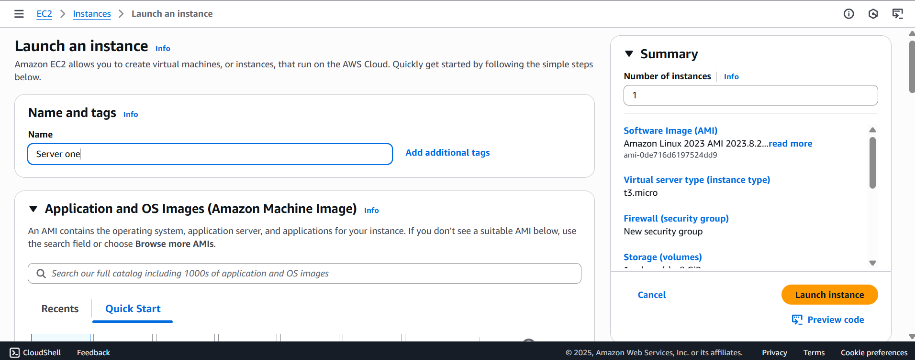

In security group I added port 22 and 80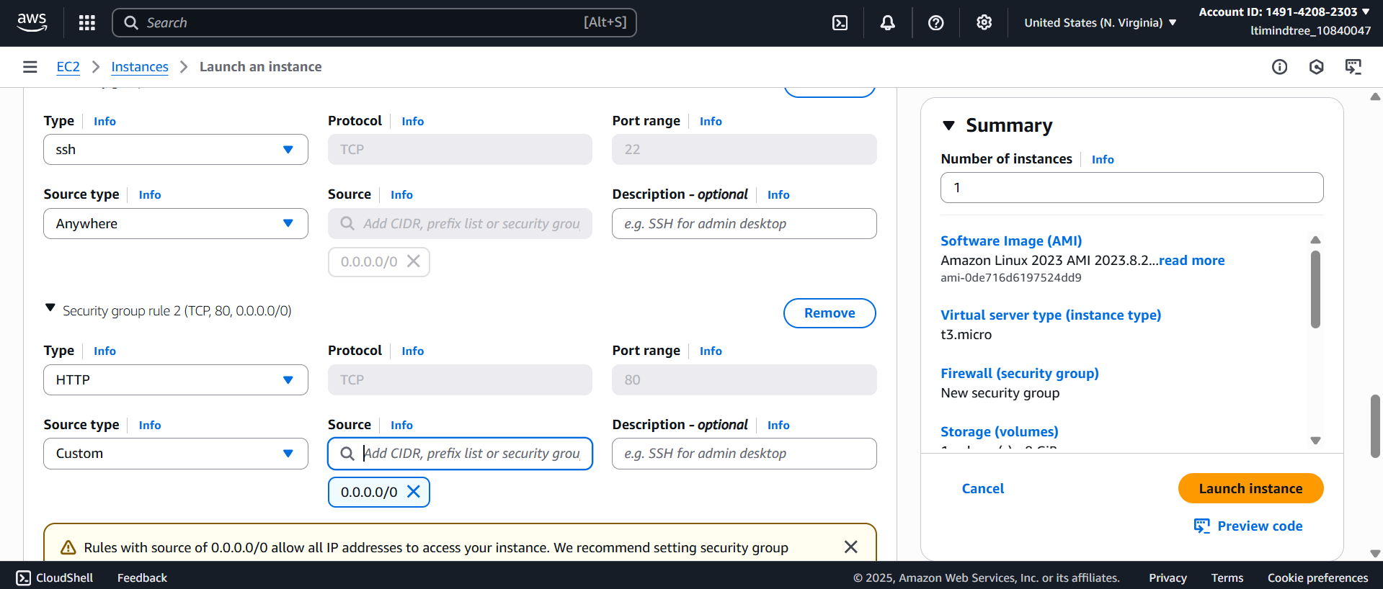

Then i added the script to run the apache server.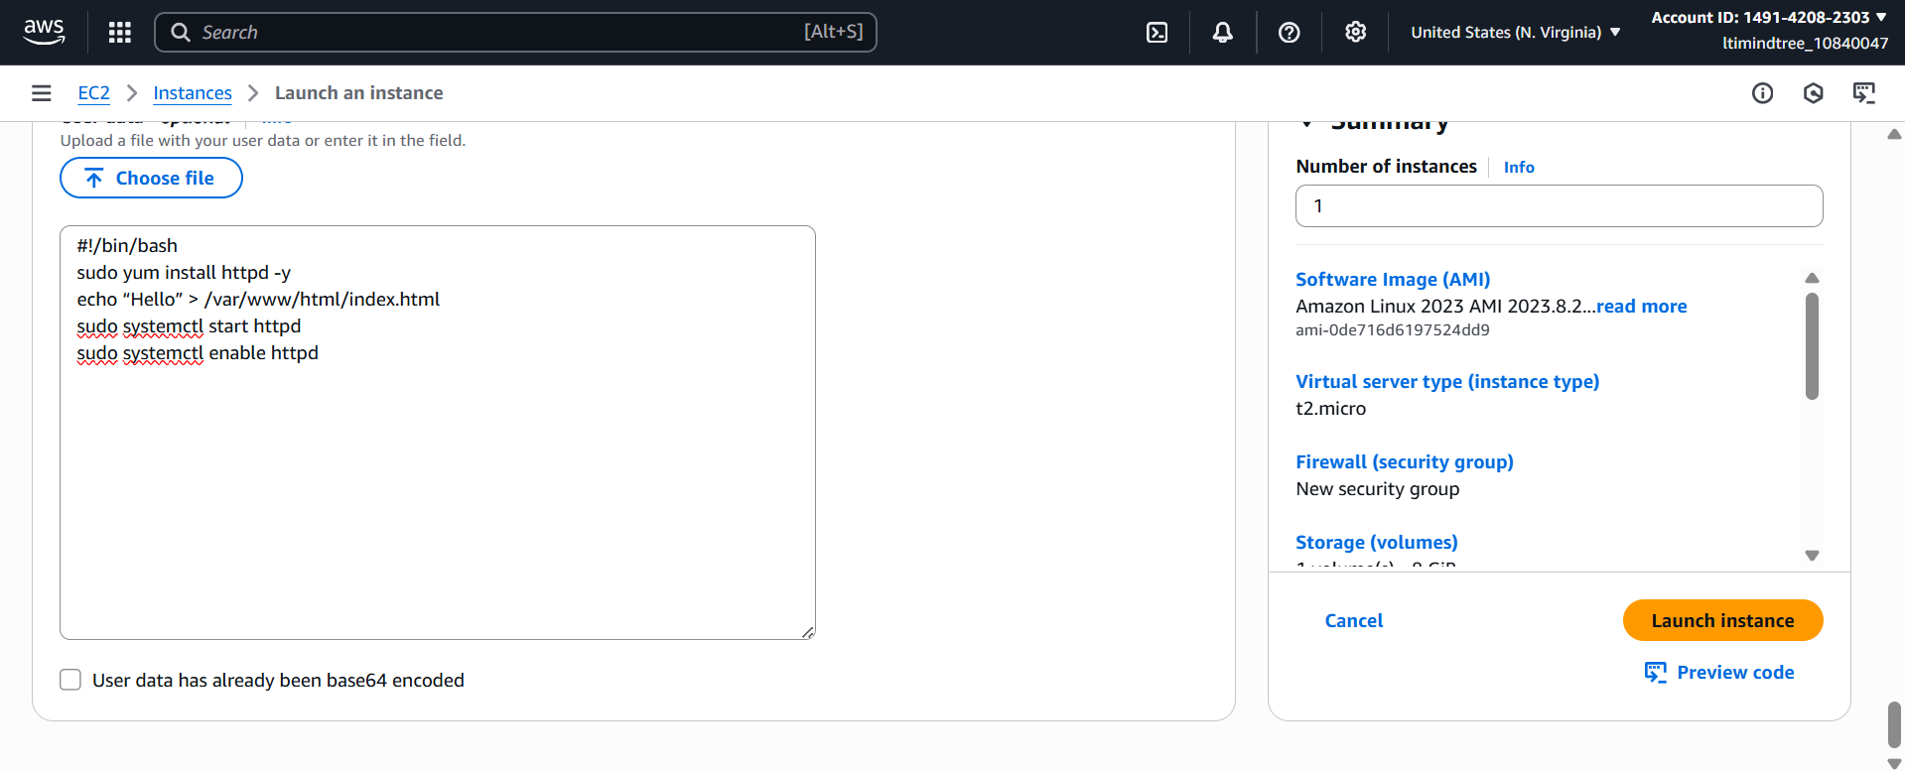

Then I launched an another instance with same security group and the script.

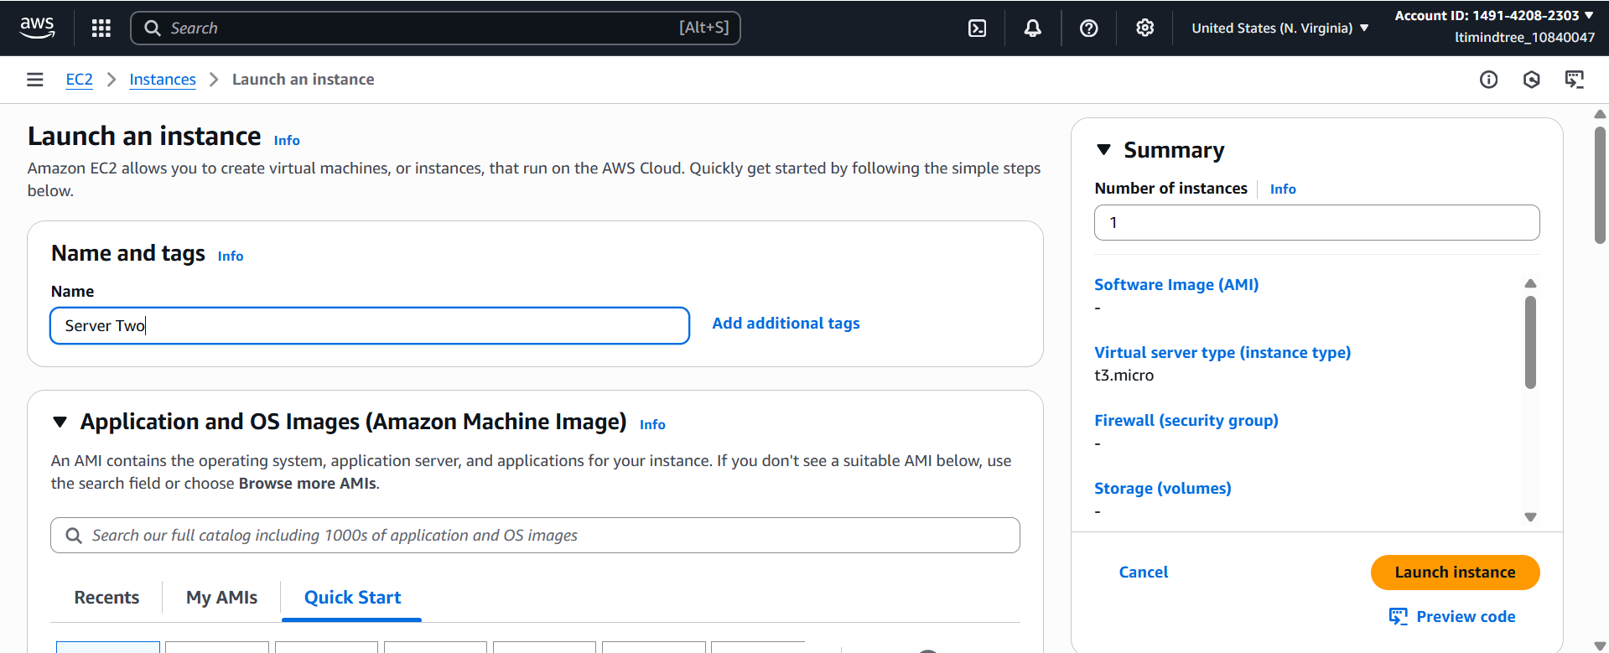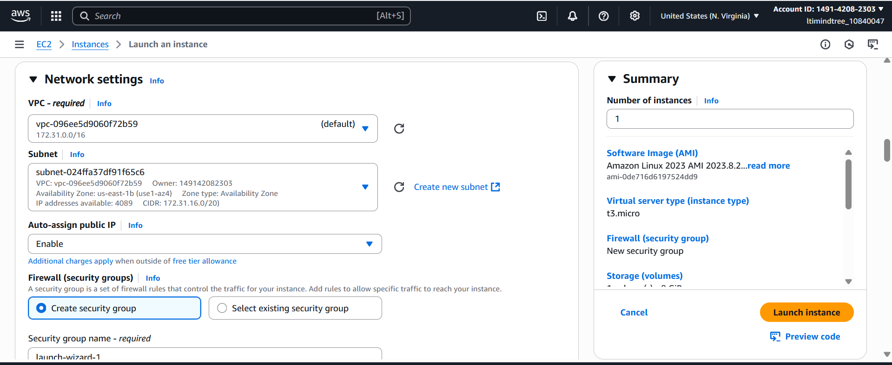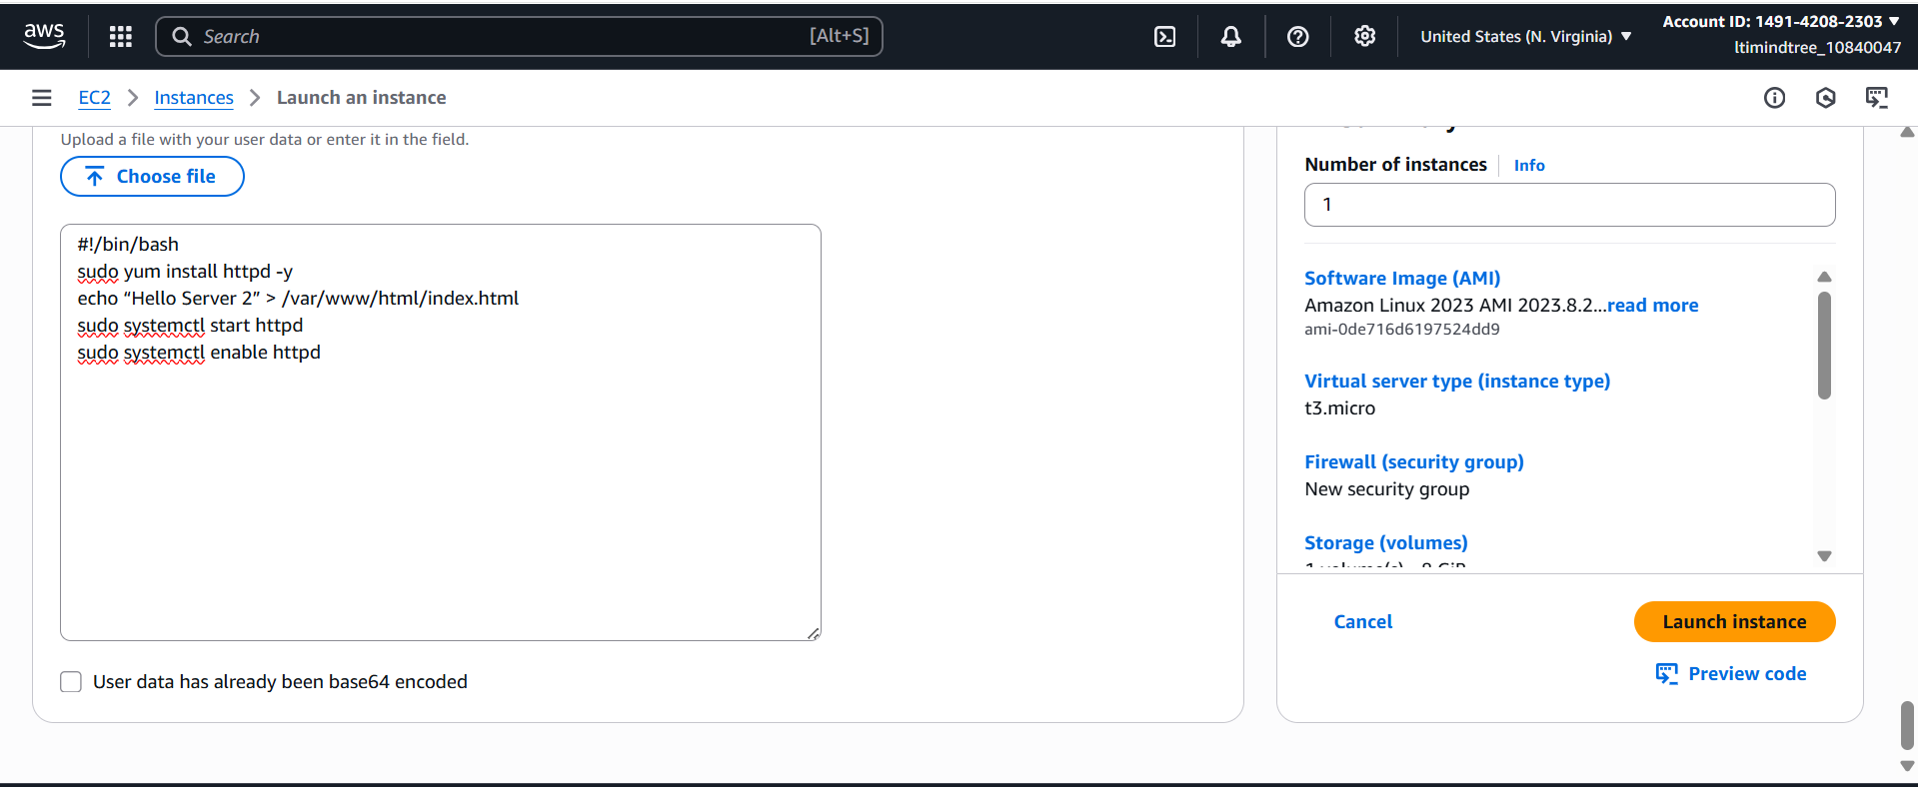

Then I copied the public ip of both the instances and pasted it in the browser with port 80 to check if it’s working 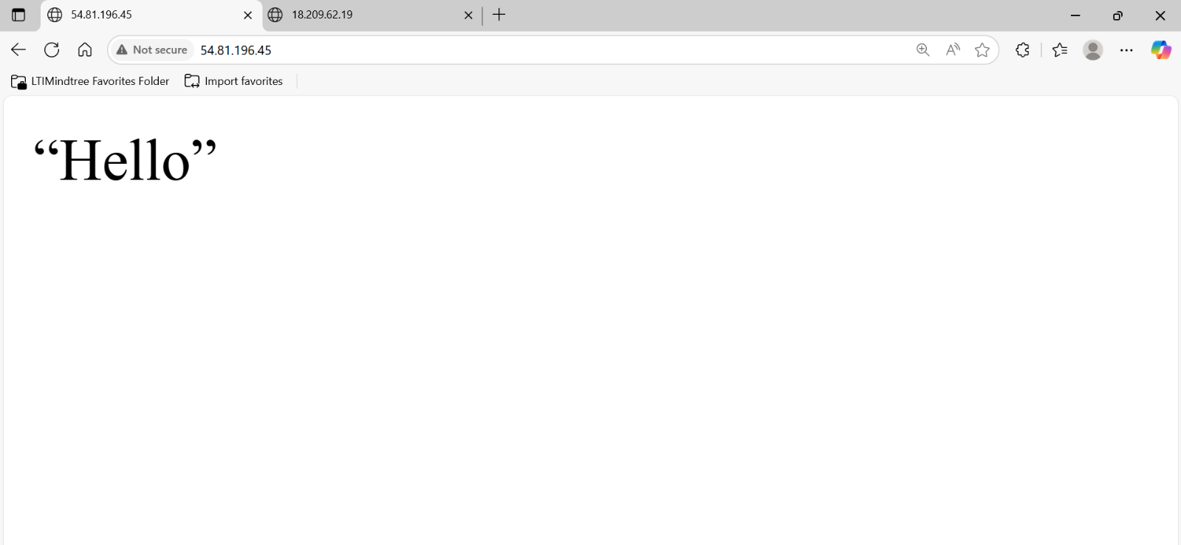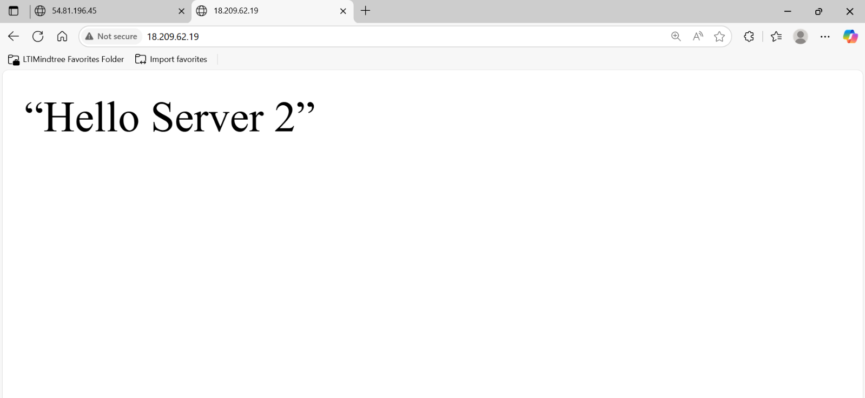

I went to Target groups section and created a target group.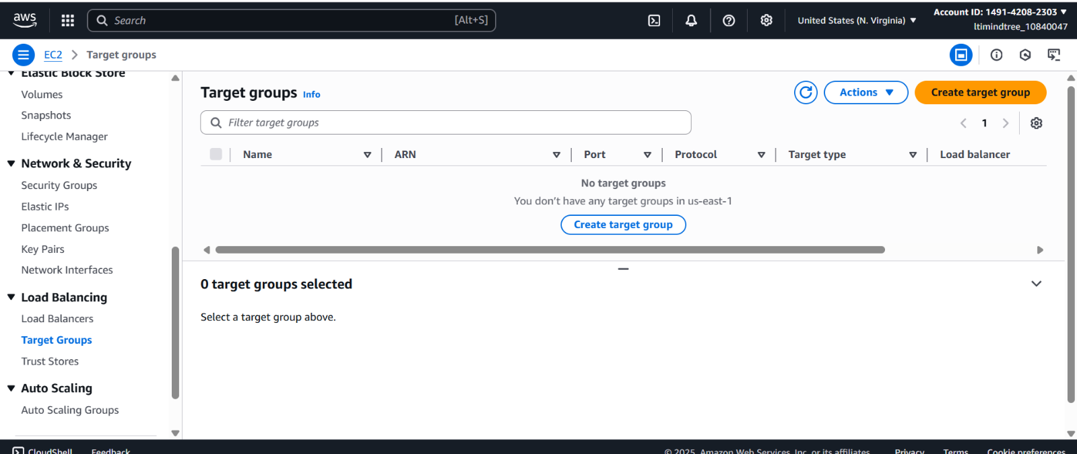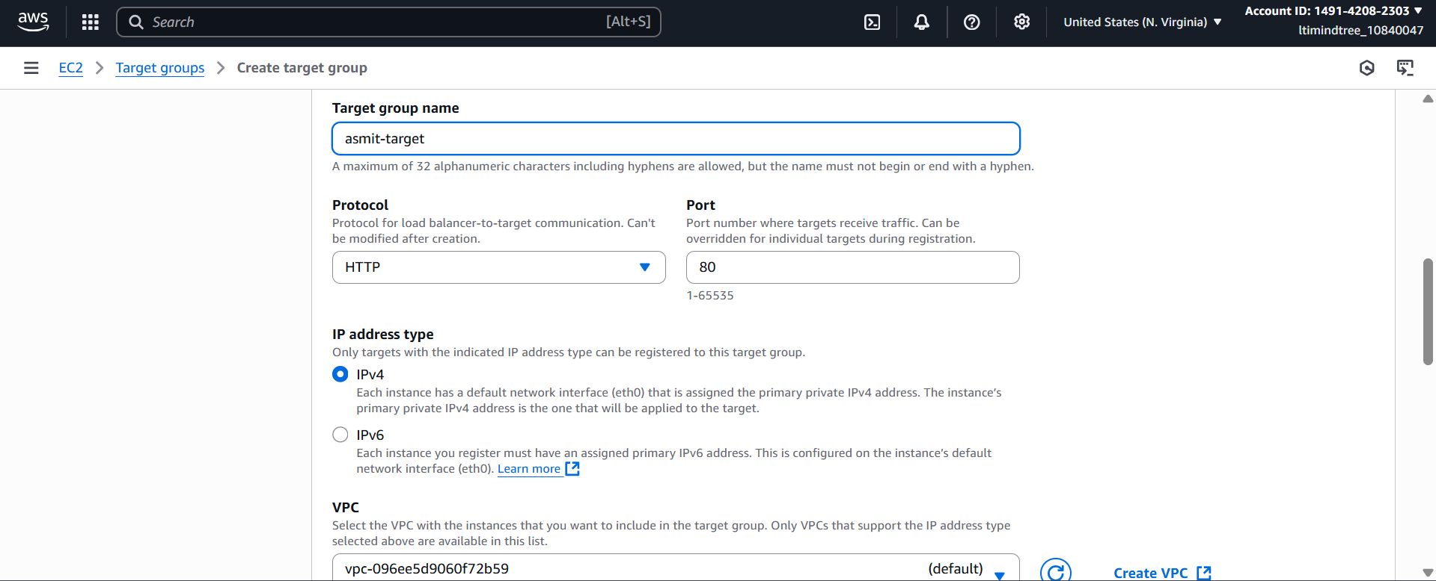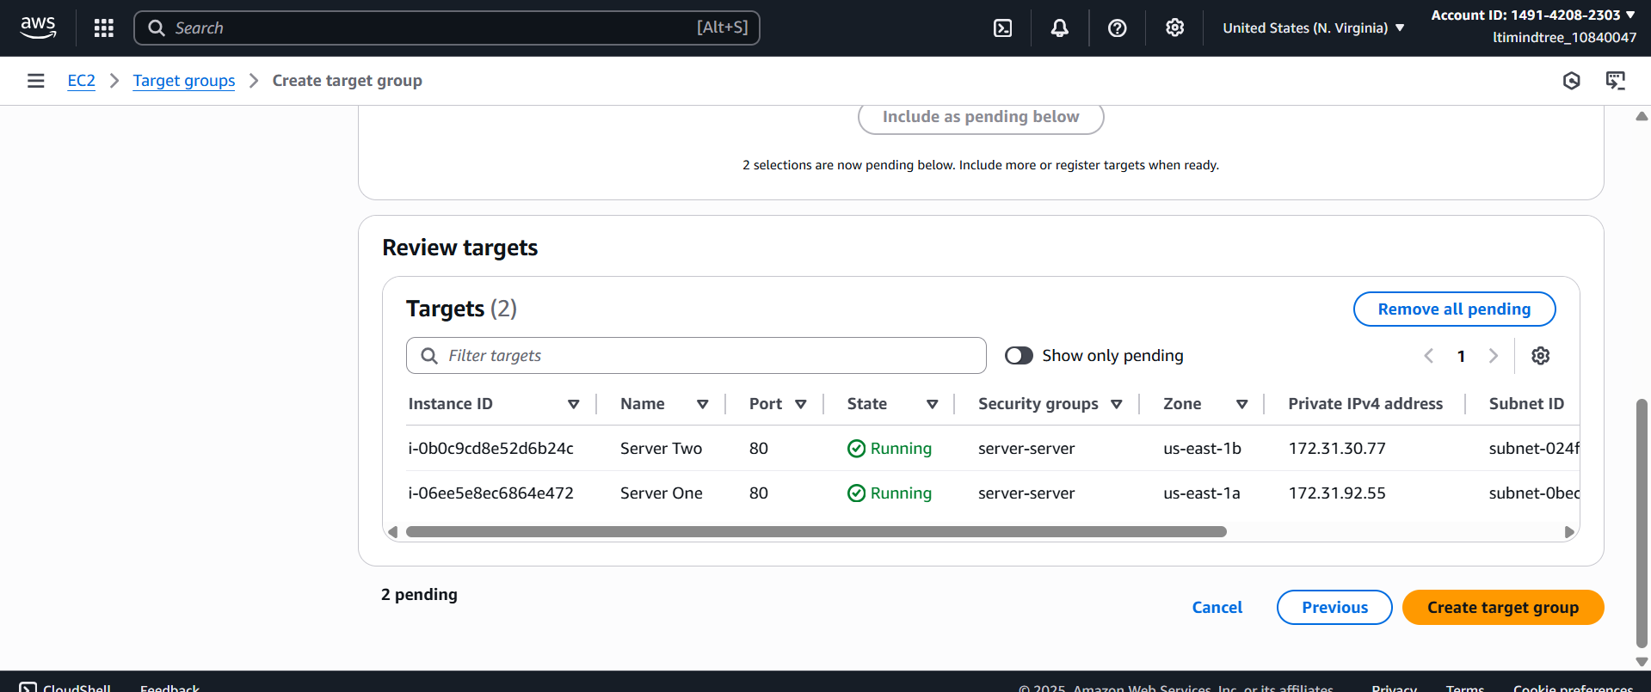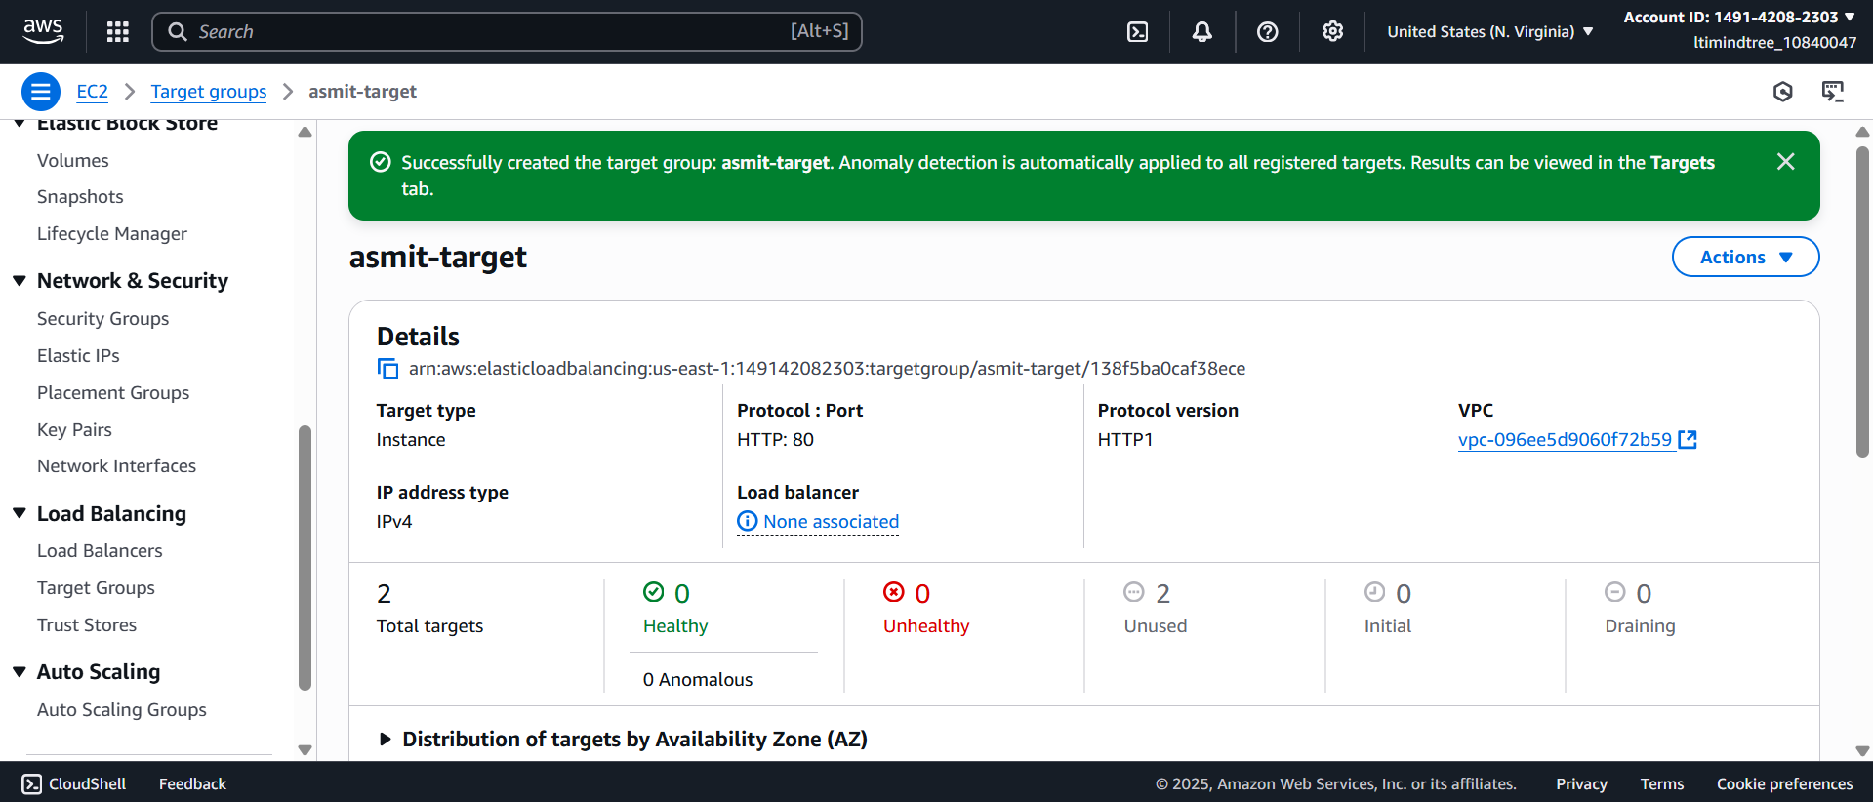

Then I created a load balancer with the target group I just created.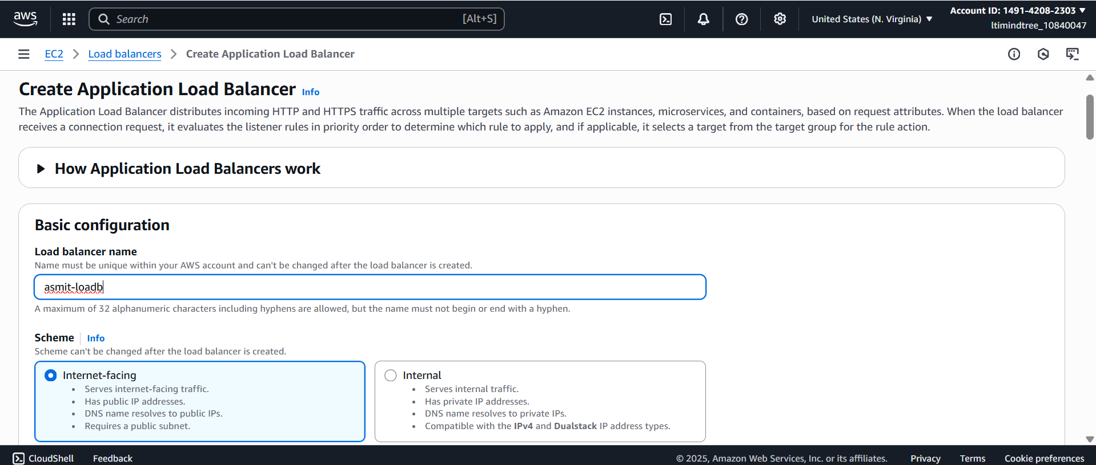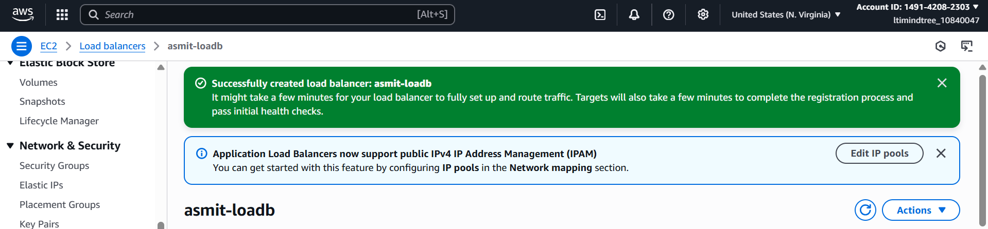

Then I cpoied the dns name of the load balancer and pasted it on the browser and when I kept refreshing the page was getting switched between the instances I created. 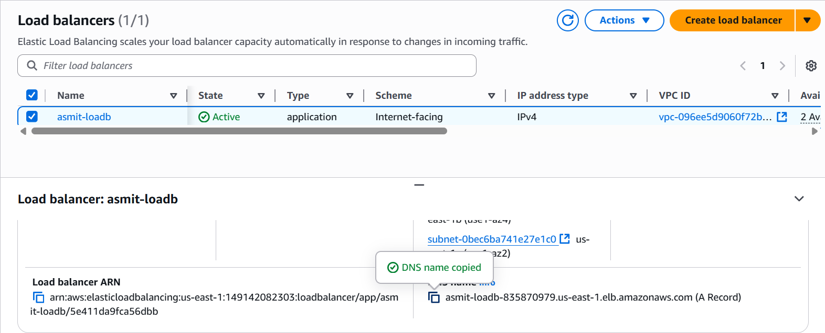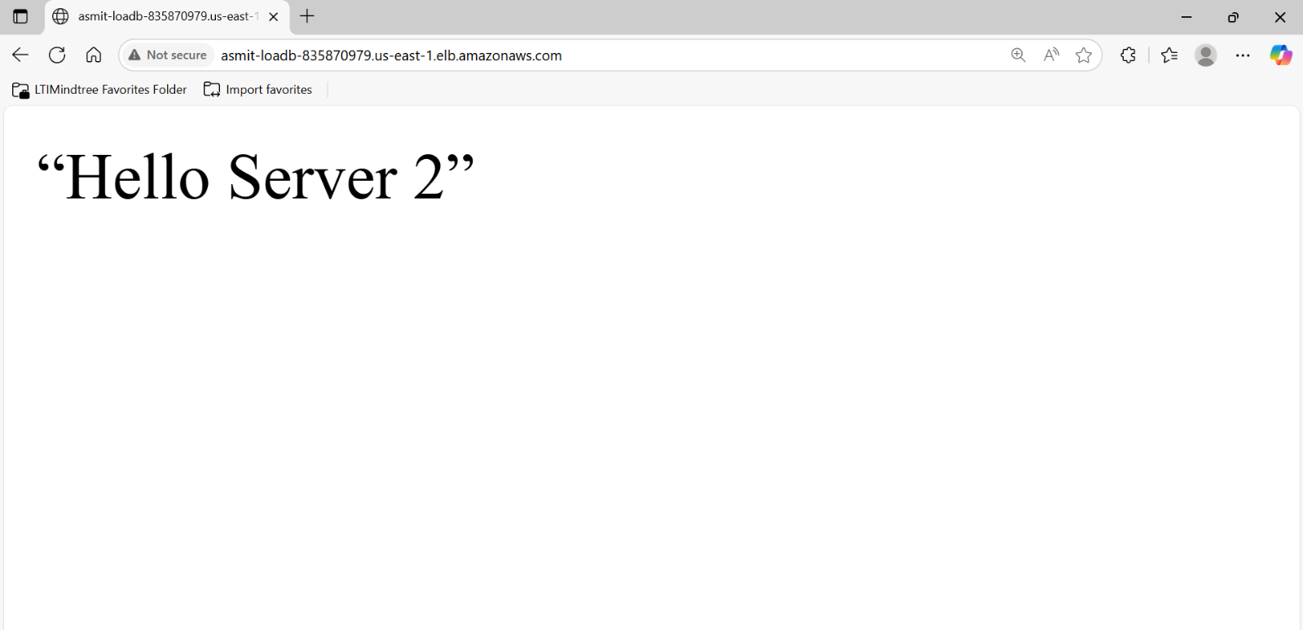

**My one team is working within Mumbai India Region, and they have some important data in the ebs volume, and another team is working within Singapore region. They also want to access same data which is available in Mumbai Region. Share it in different regions.**

First, I created an instance in N. Virginia, since Mumbai and Singapore were not accessible, I chose two regions N. Virginia and Ohio.

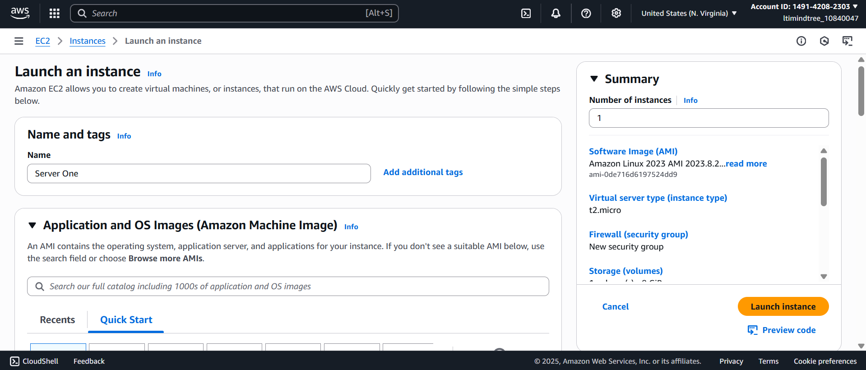

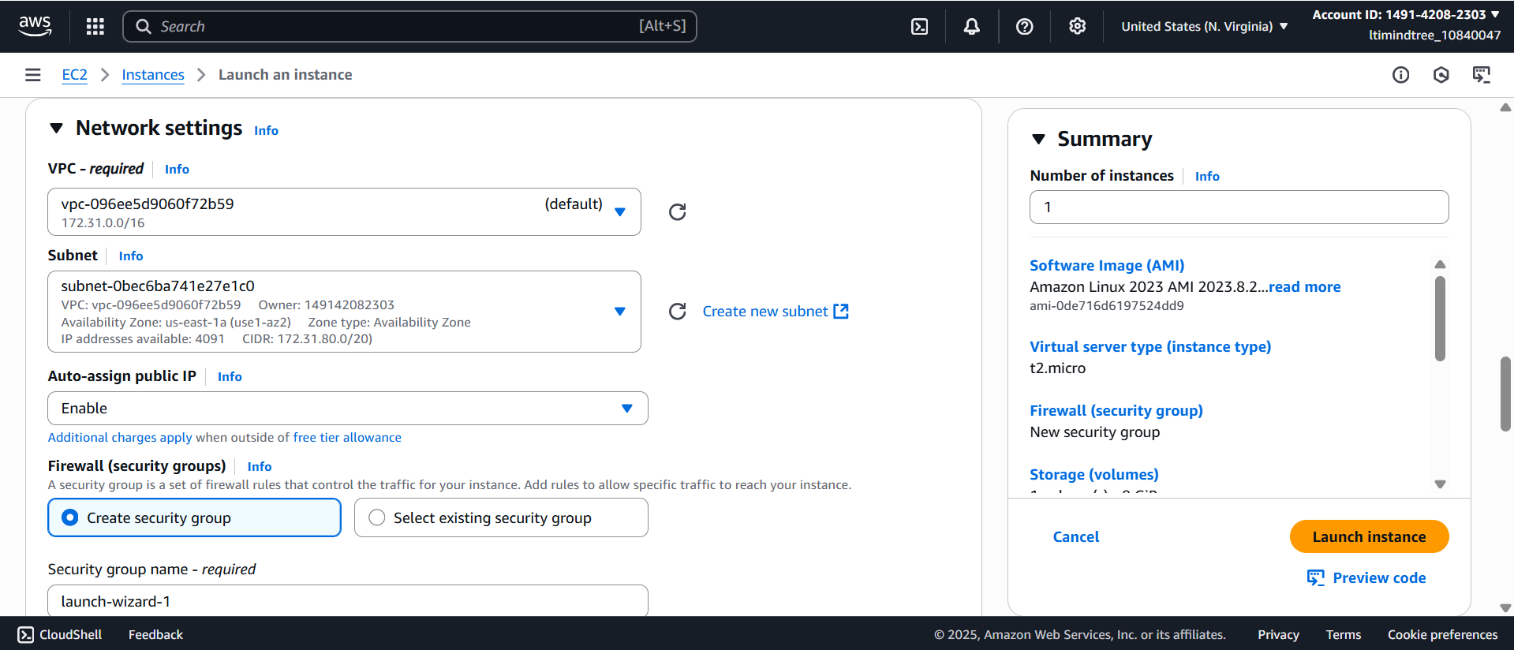

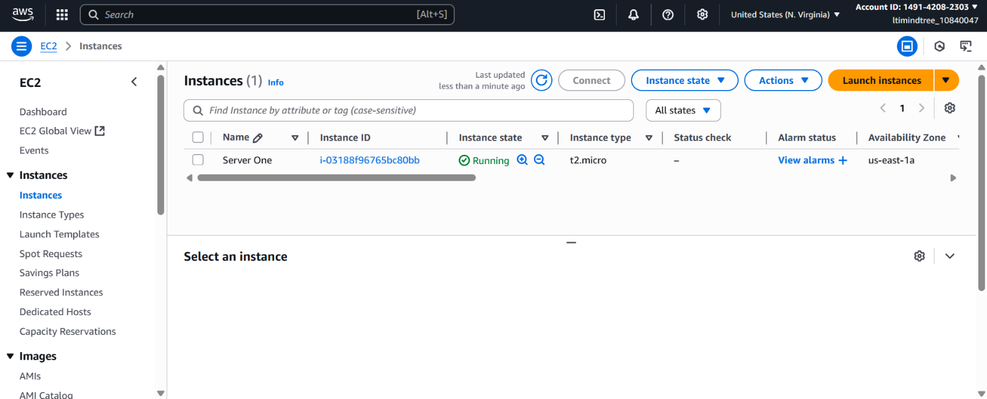

Then I created a volume of 5 gb of gp2 type and attached it with the instance I just created.

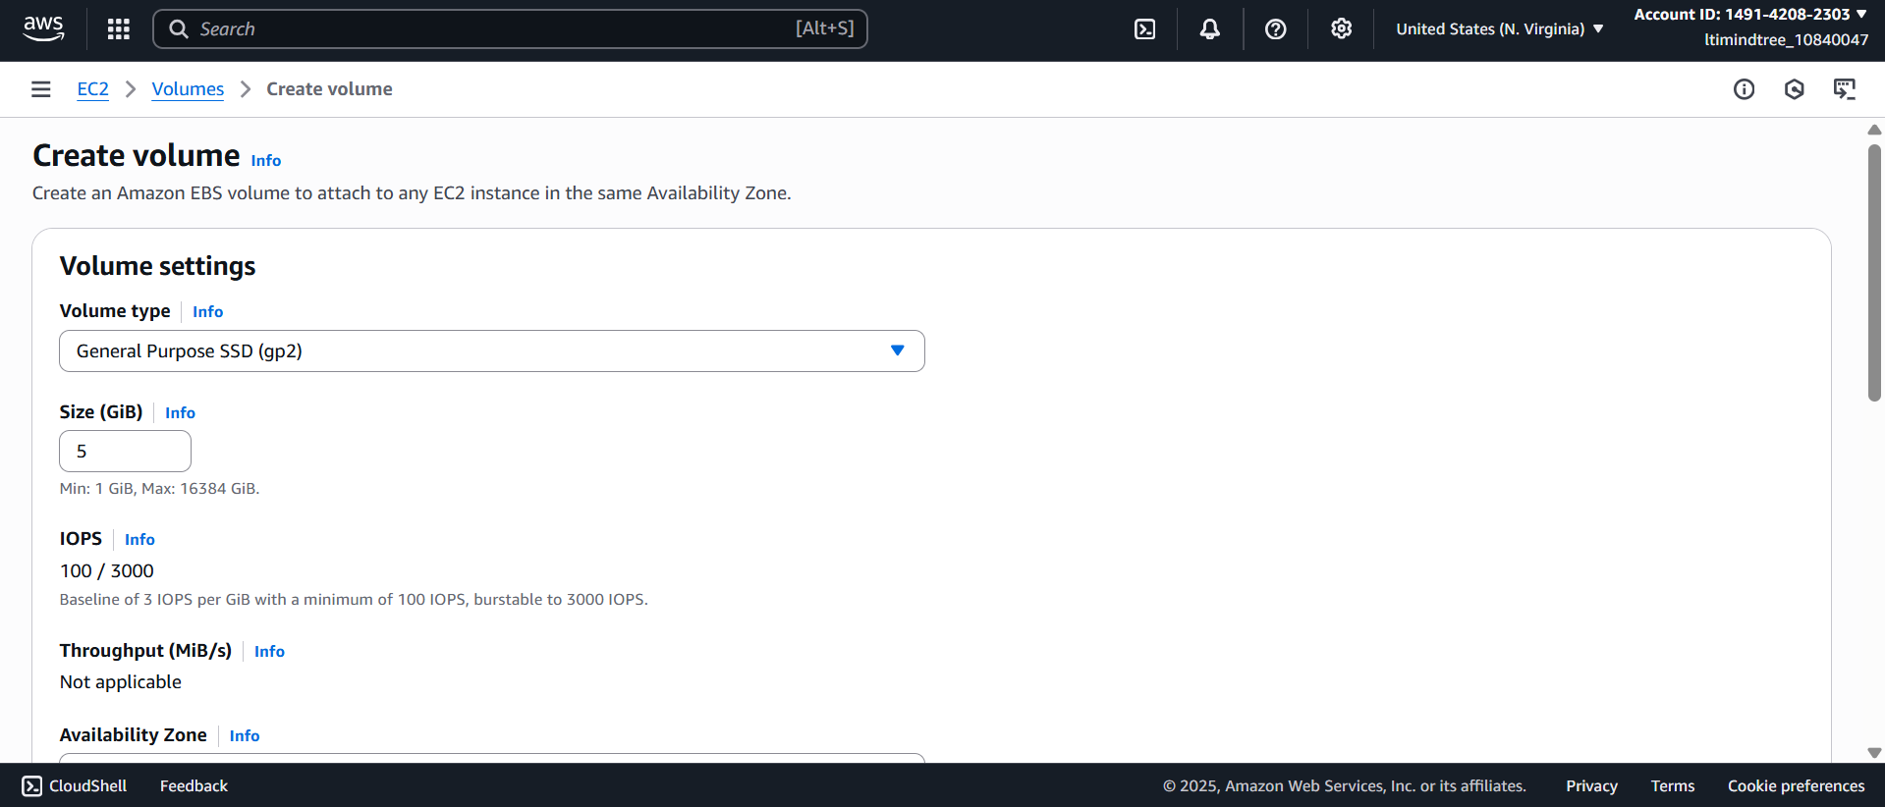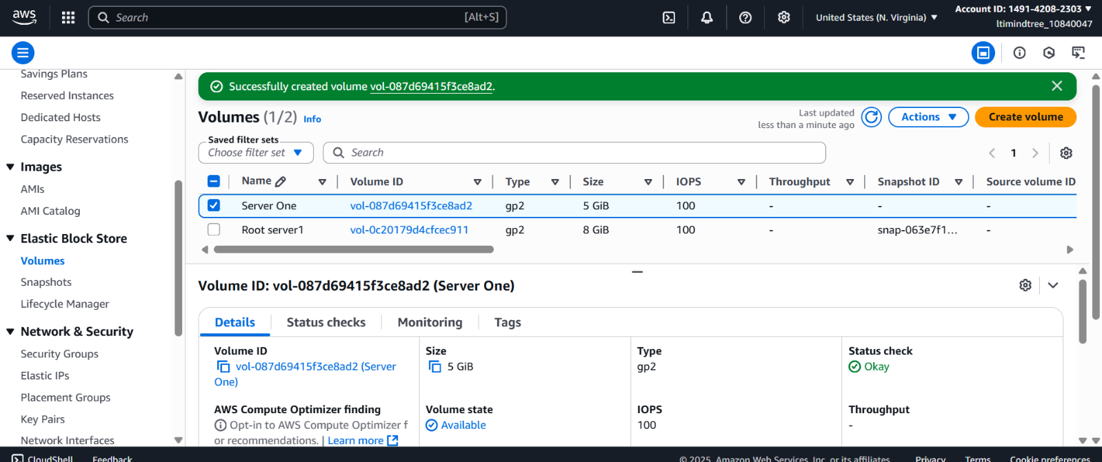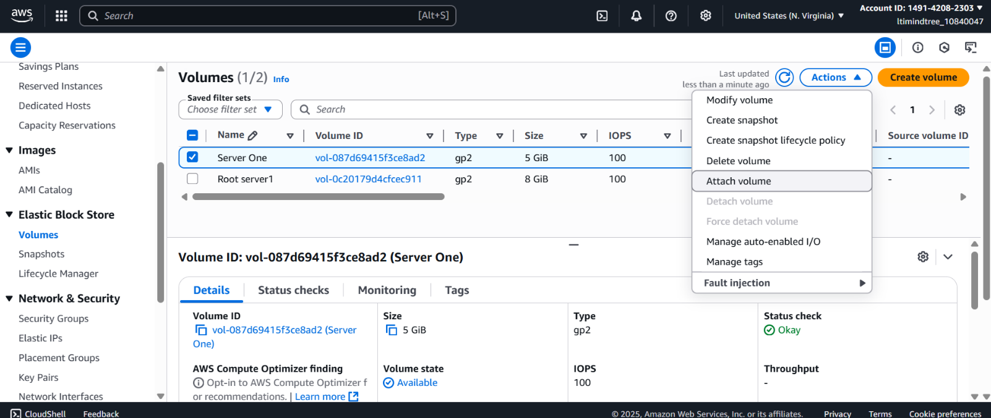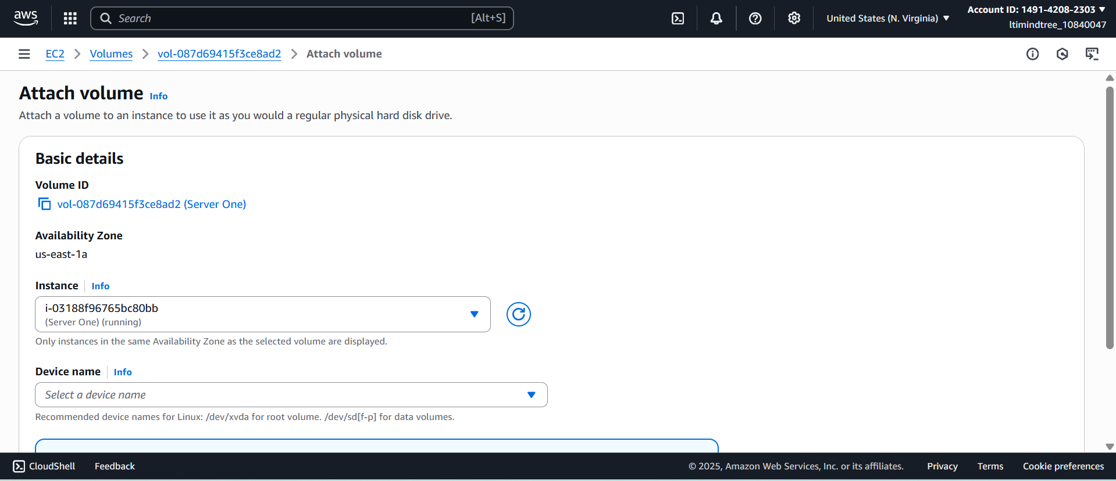

Then I launched the server in my terminal.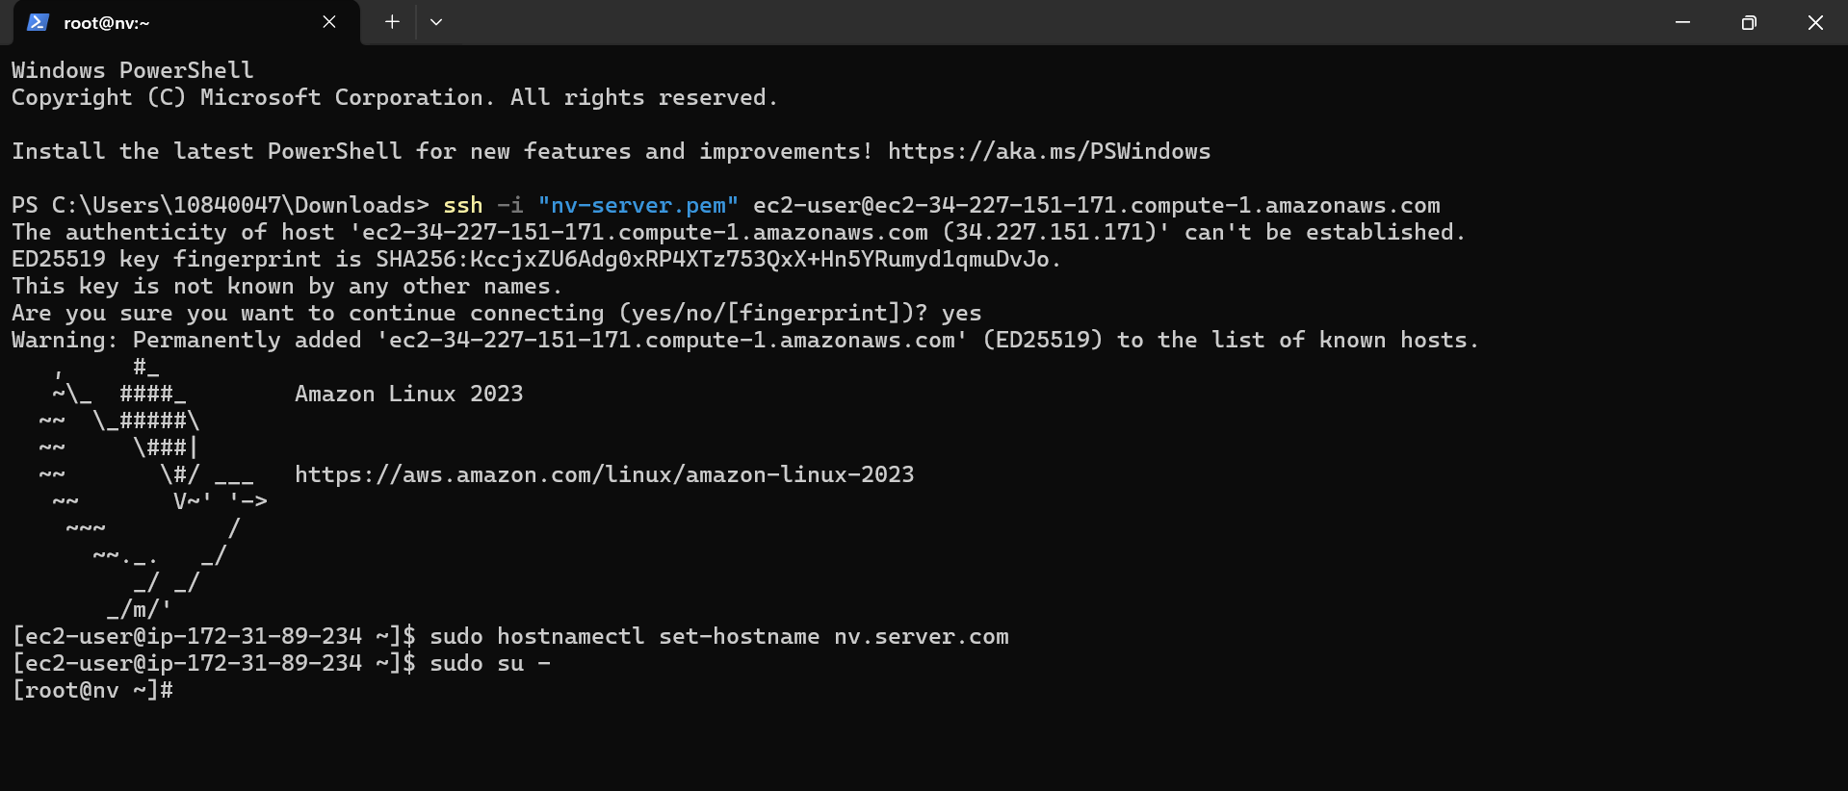

Then I ran command lsblk to check the new volume and gave file system ext4 to it and then I mounted the disk in /data.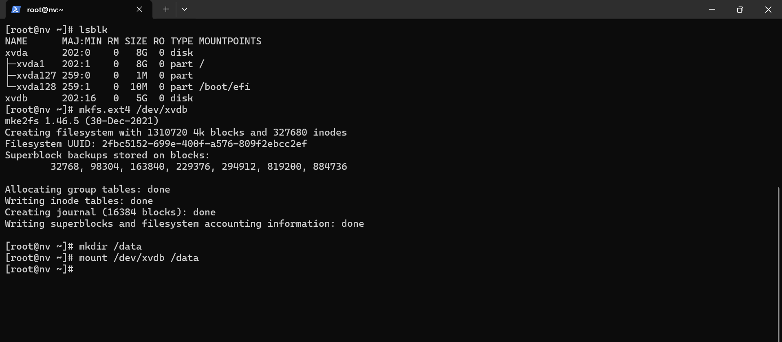

As this mounting process is temporary so to make it permanent, I added the below text in

vim /etc/fstab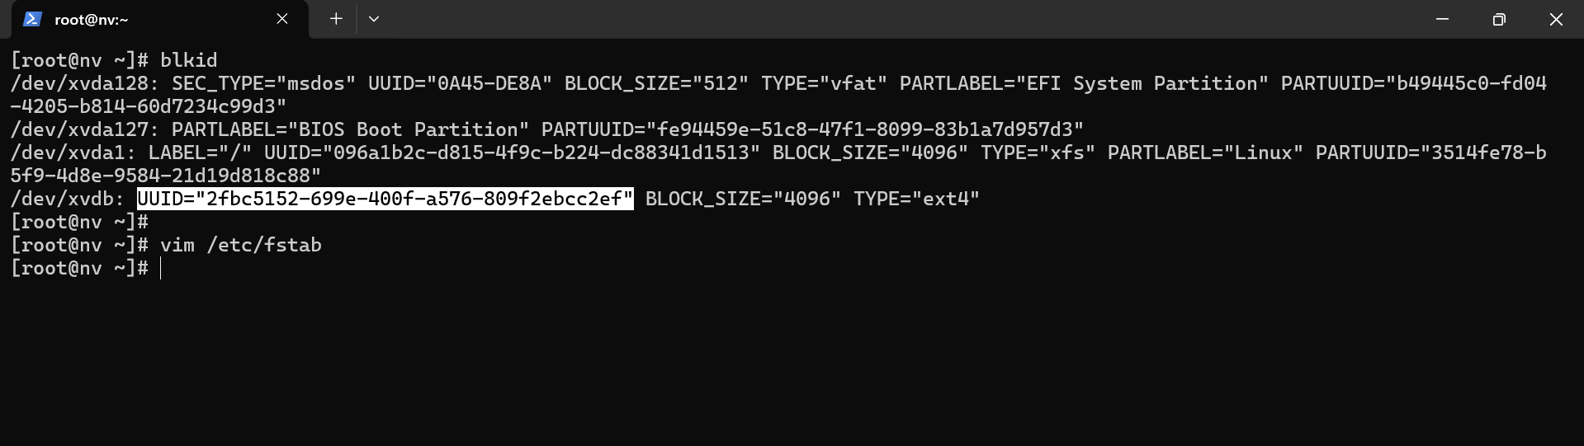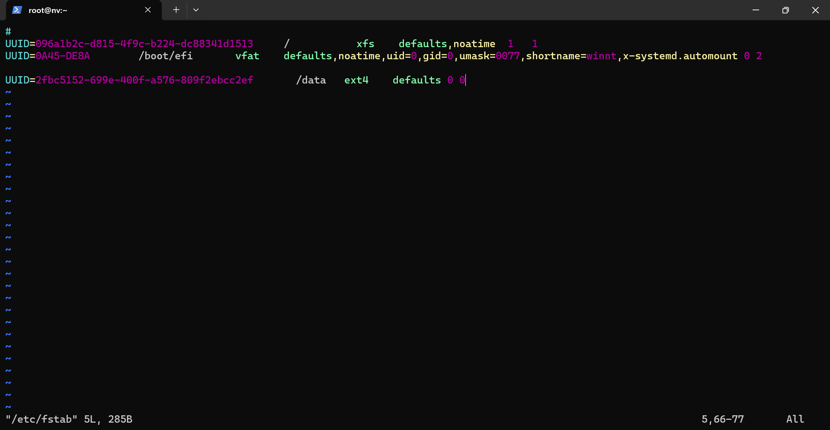

After mounting the changes, I created 10 files inside /data to check if it’s reflecting in the another region.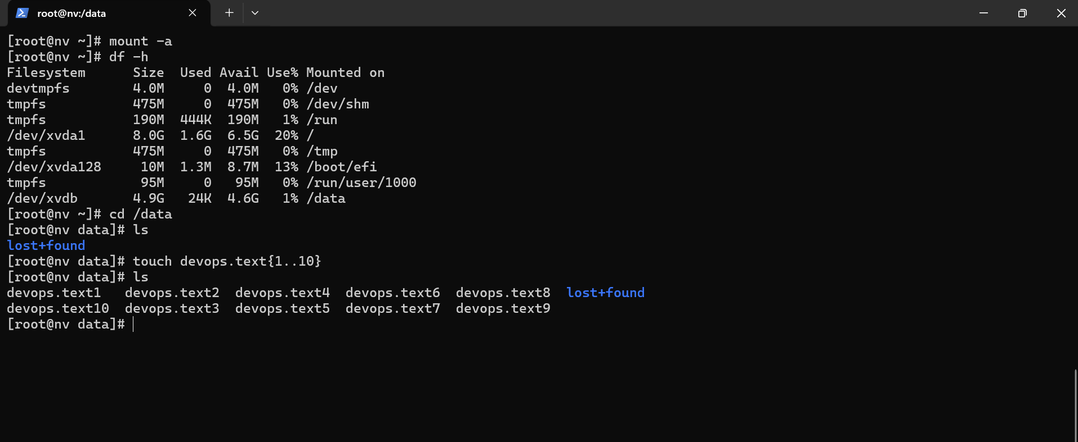

I created a snapshot of that volume.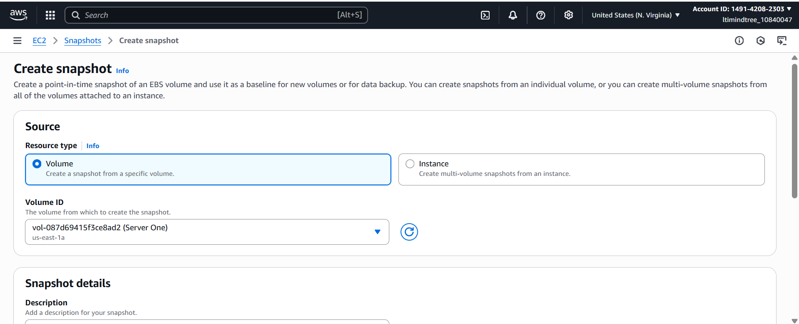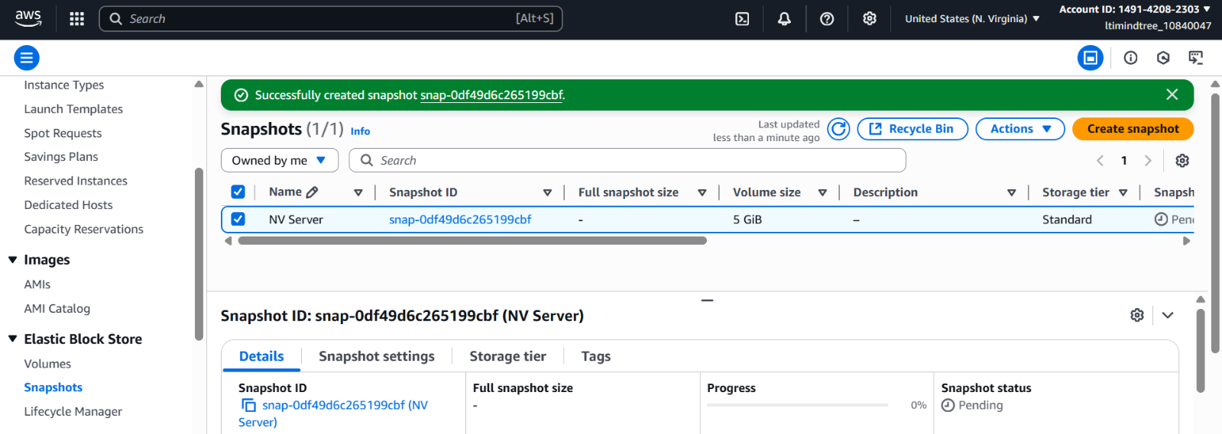

Then I copied the snapshot to Ohio region.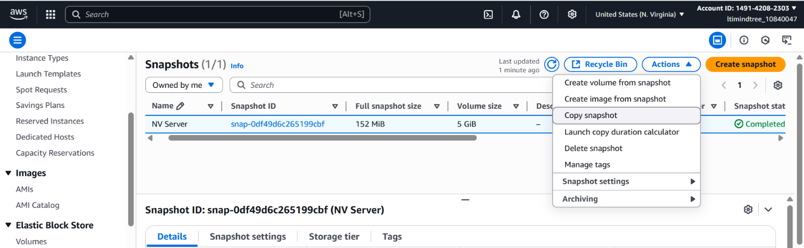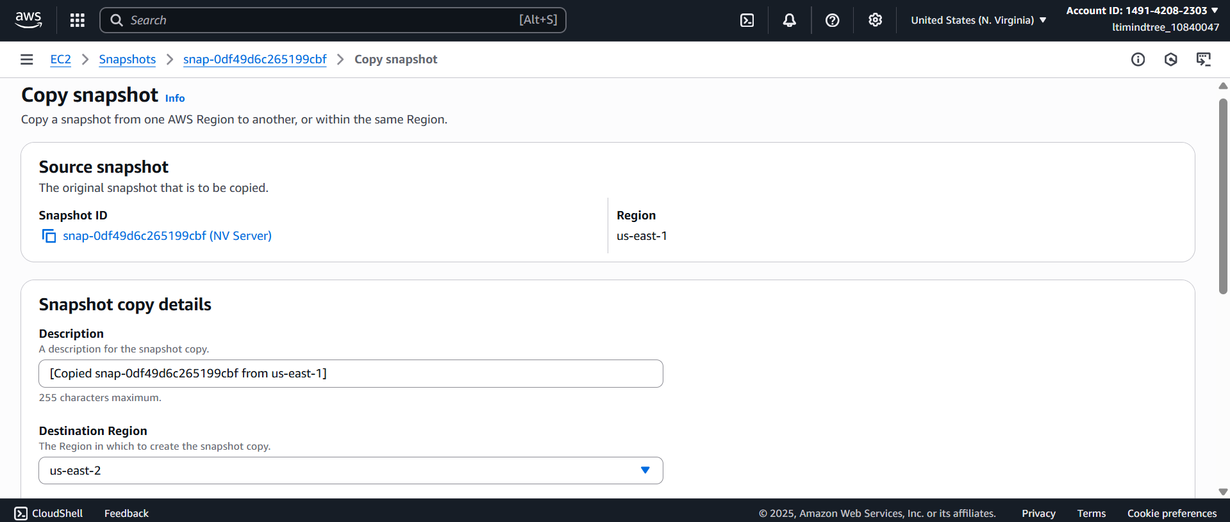

In Ohio, the snapshot was showing and then I created a volume from this snapshot.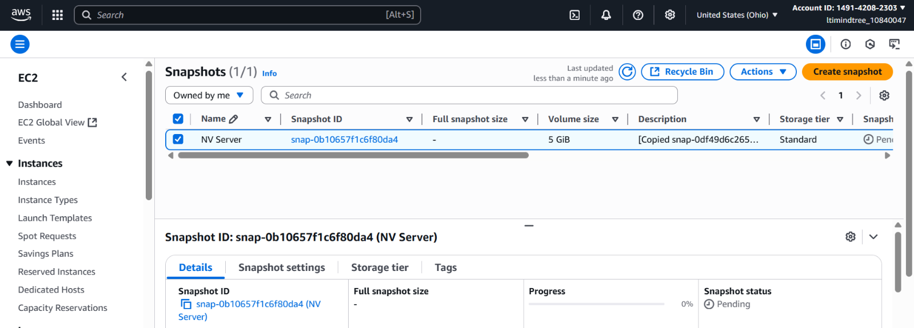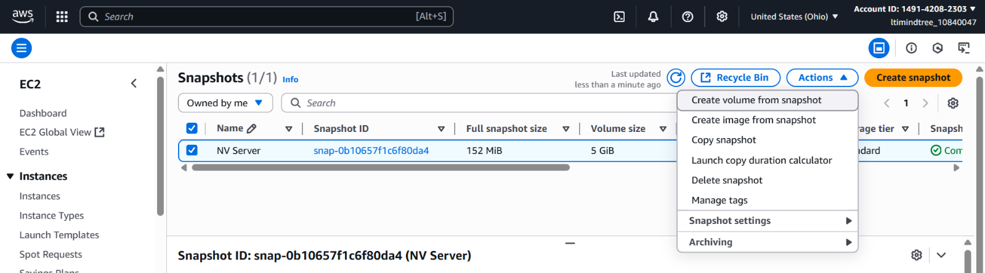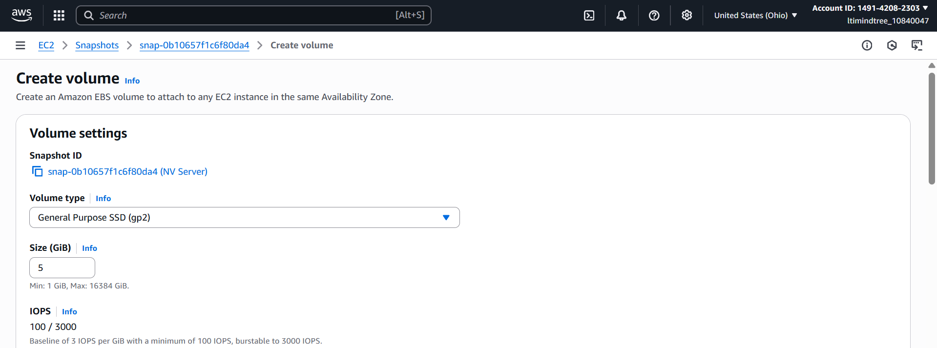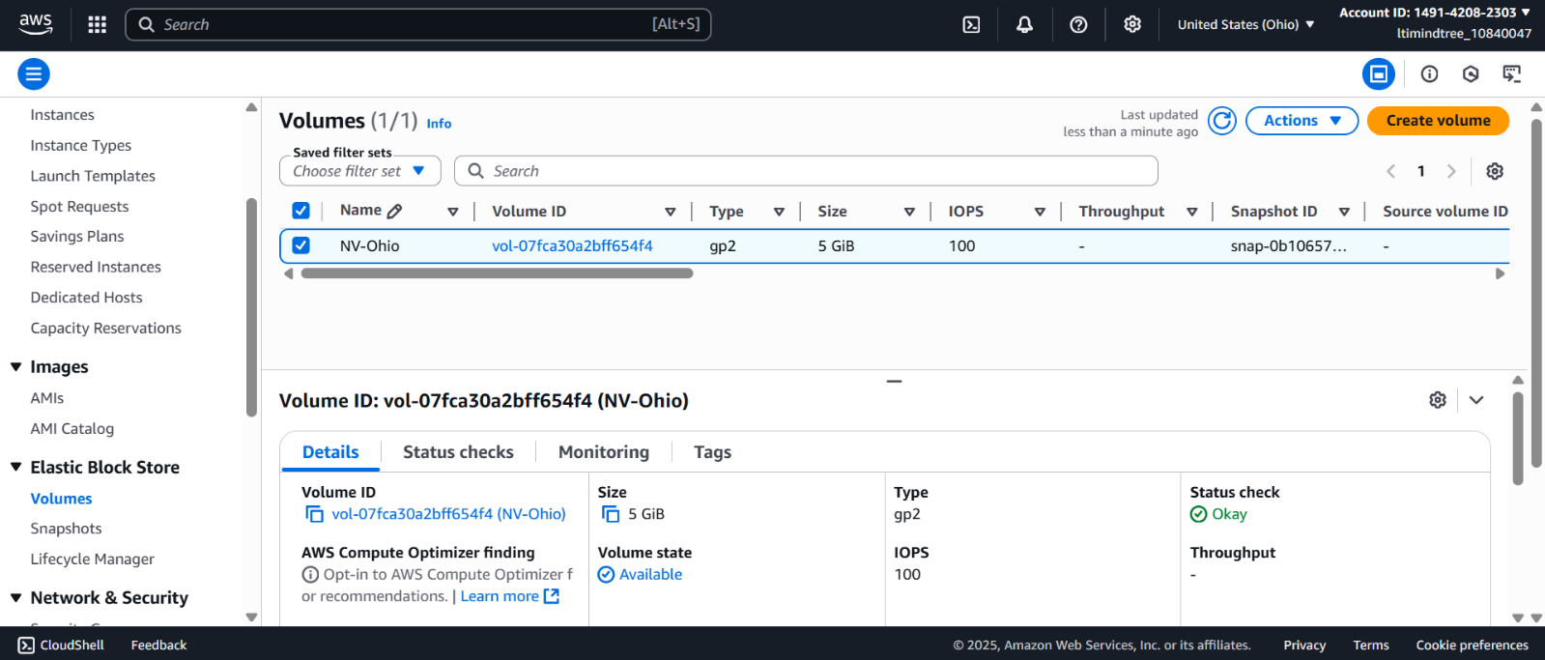

After creating the volume I launched an instance in Ohio region.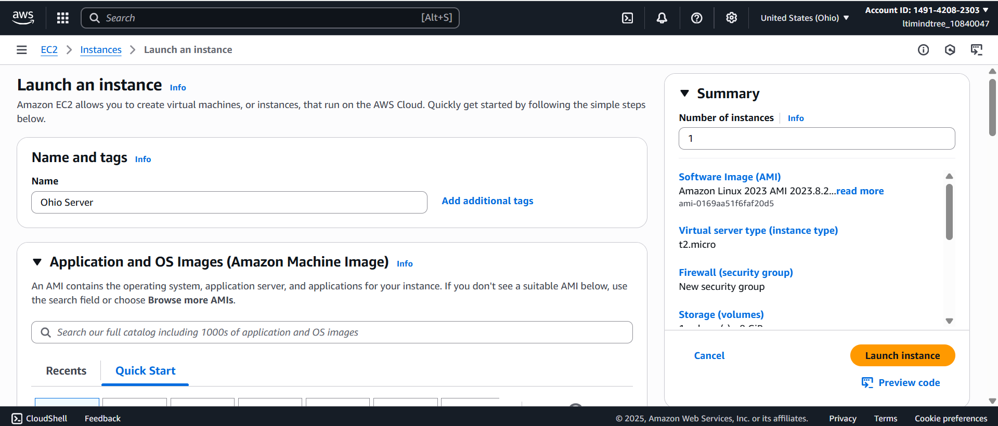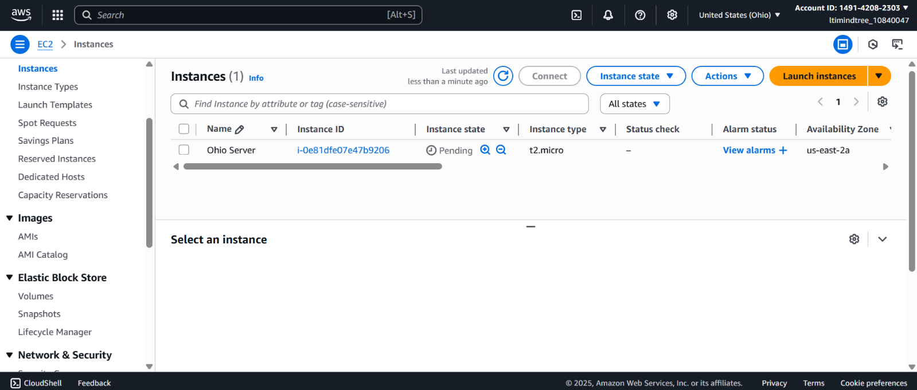

Then I attached the volume to the instance and launched it in the terminal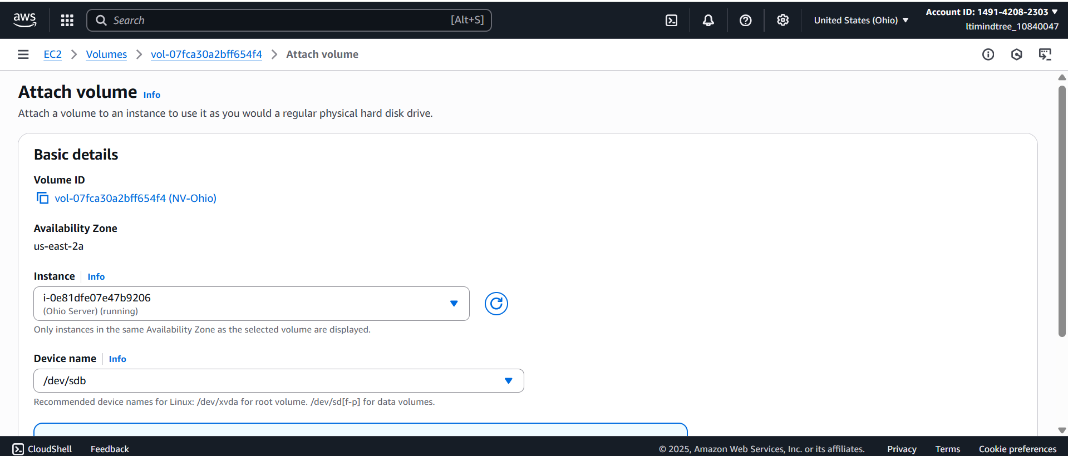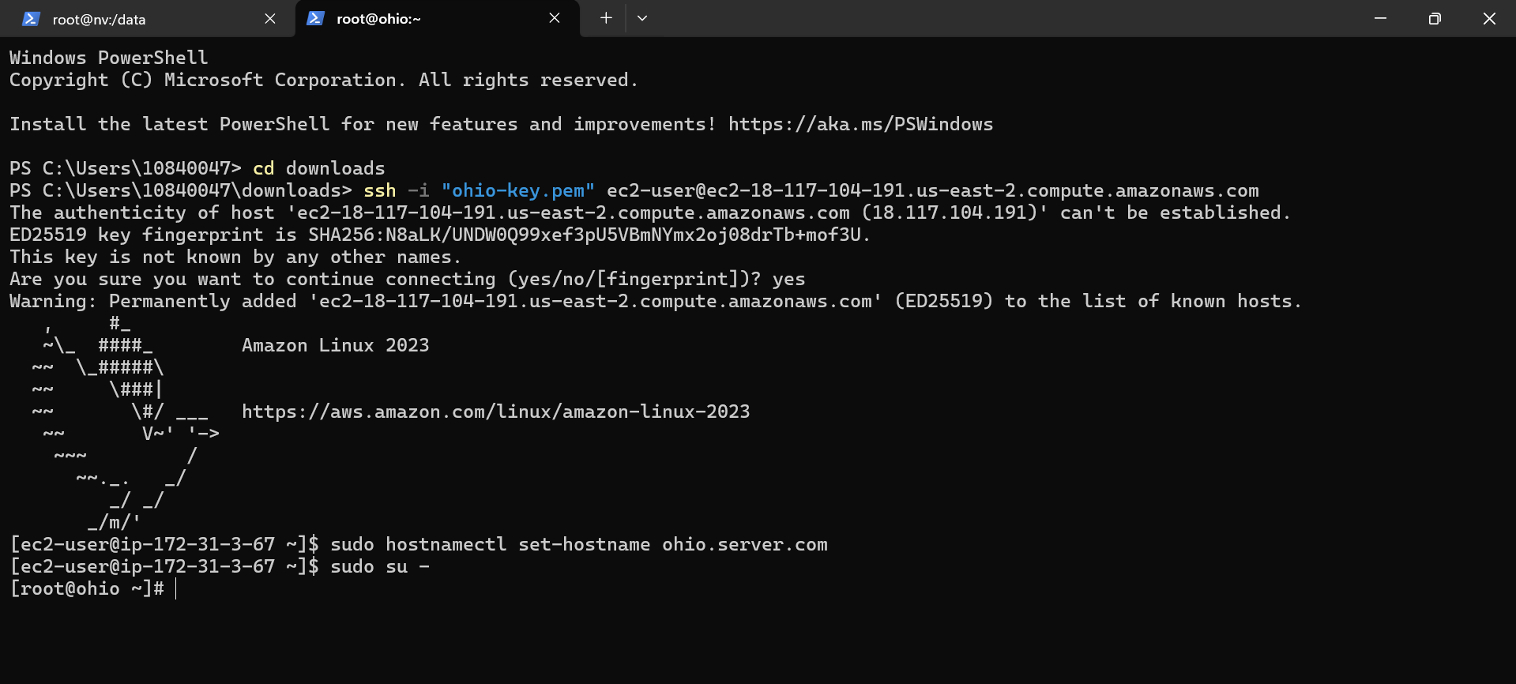

In terminal I gave file system to the disk and mounted it in the /data directory and checked if the files are present.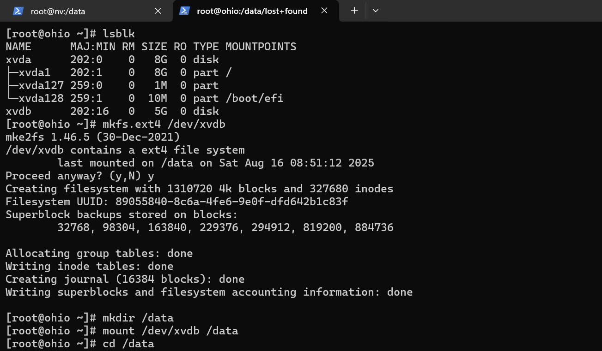

And the files were present.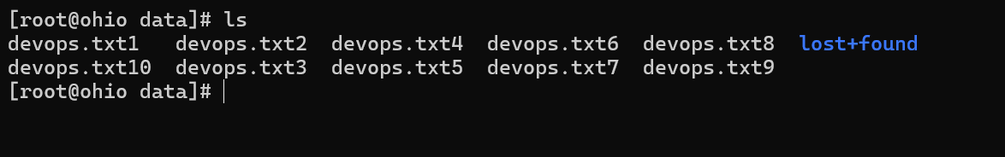

**Create two custom VPC, one in North Virginia and another is in Ohio Region. Configure VPC peering in between North Virginia and Ohio.**

At first, I created a vpc in North Virginia region.

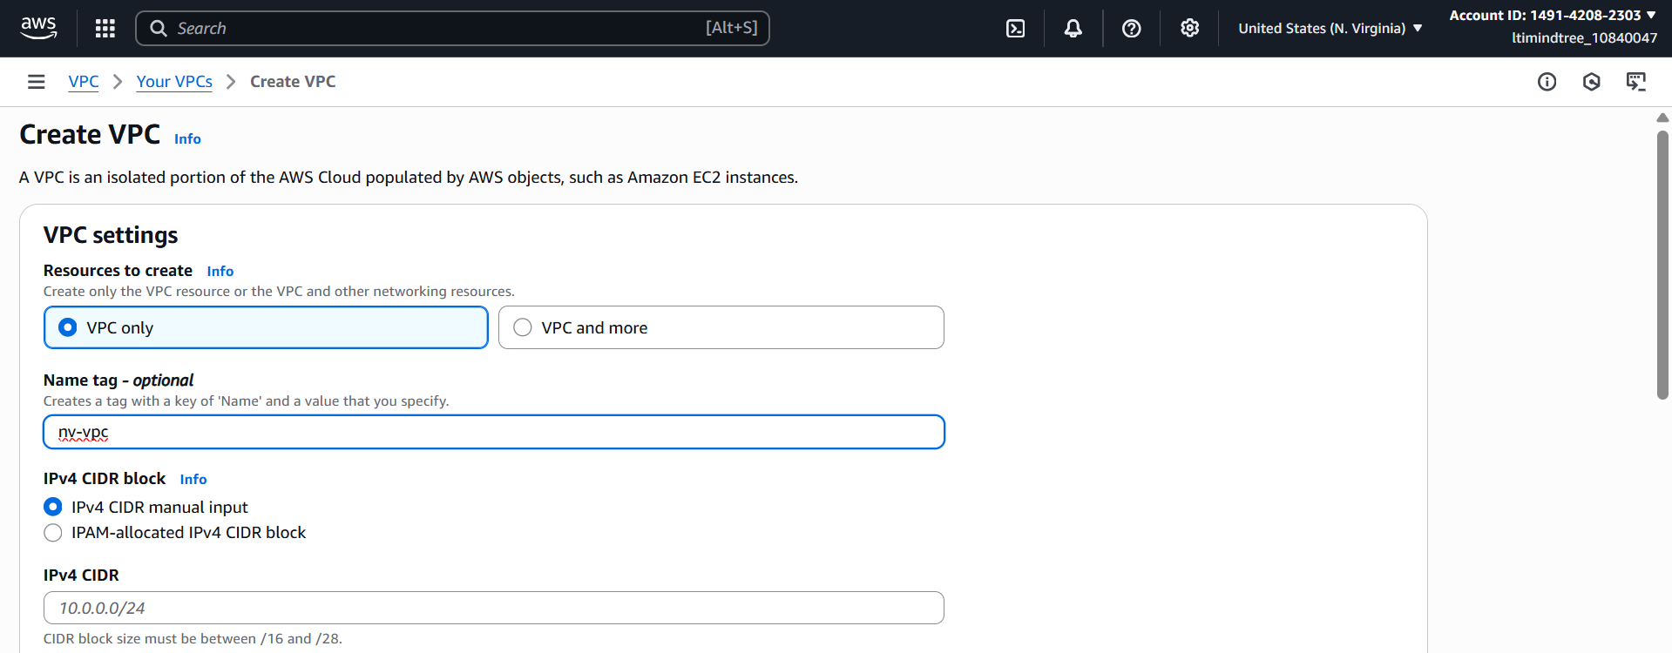 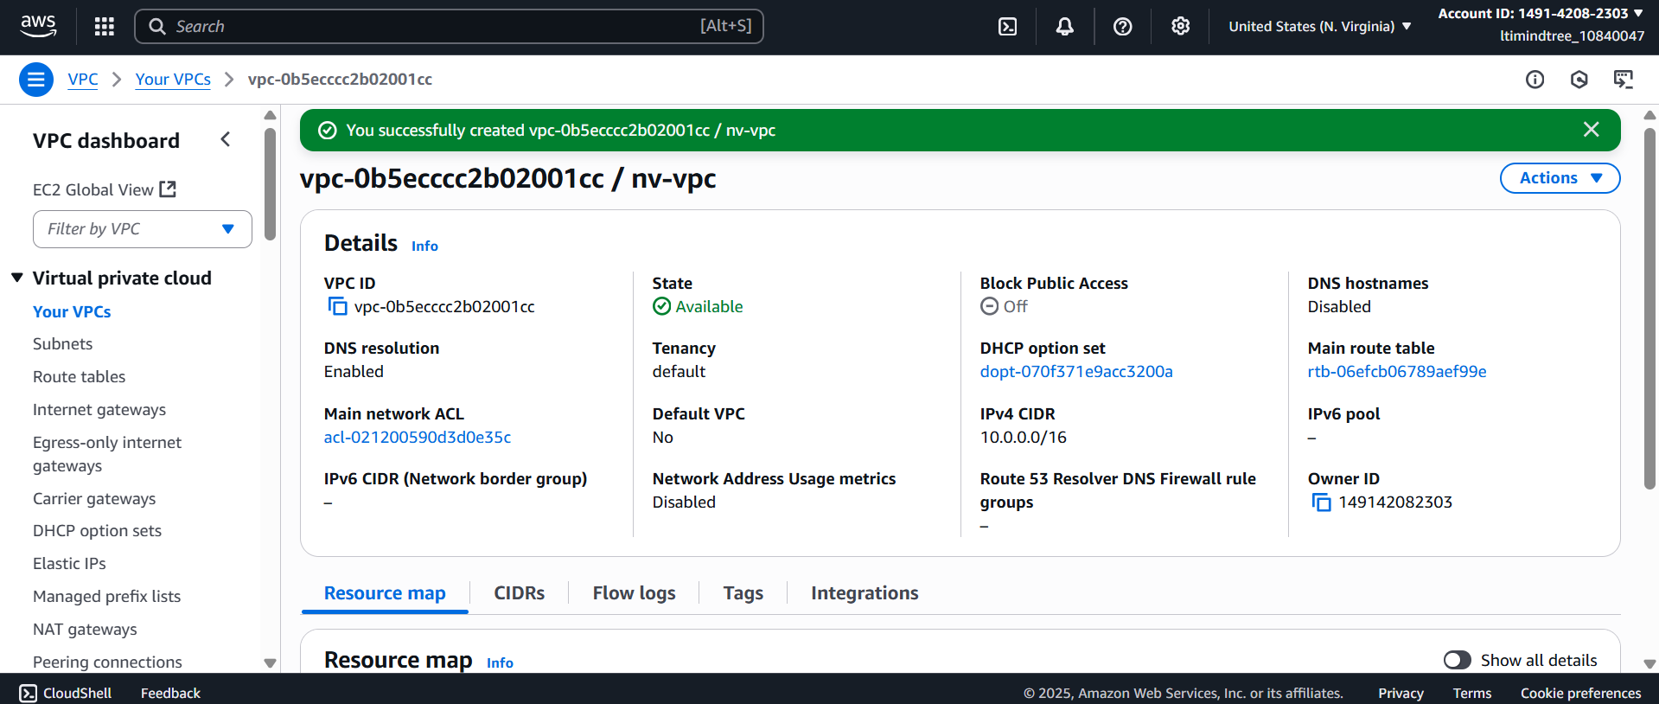

Then created an Internet Gateway and attached it with the vpc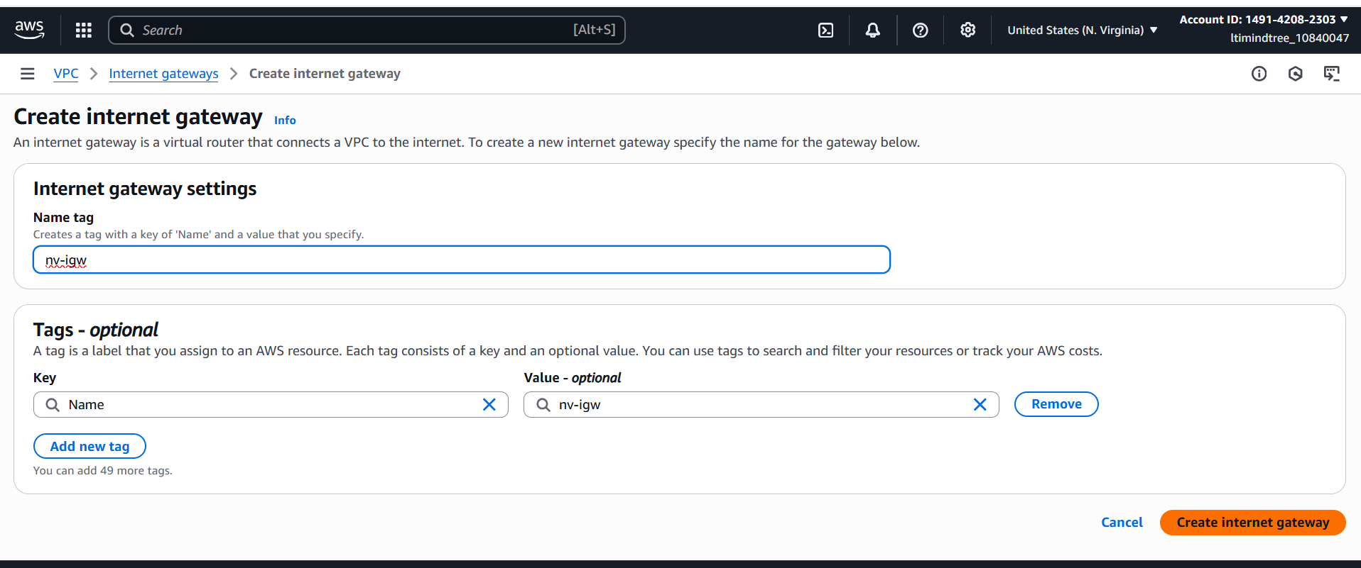 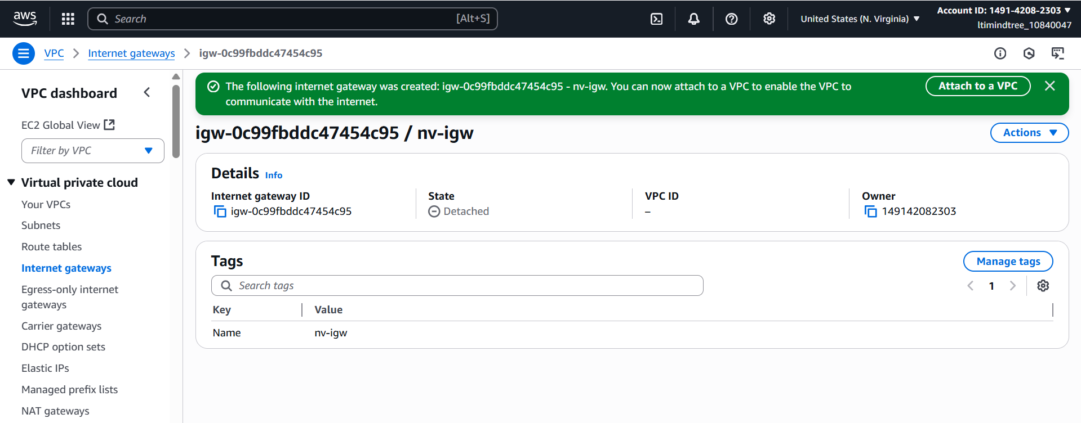 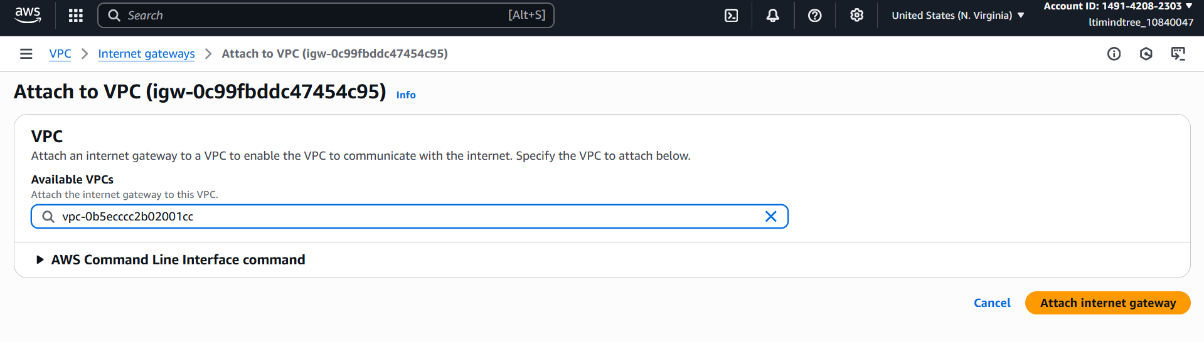 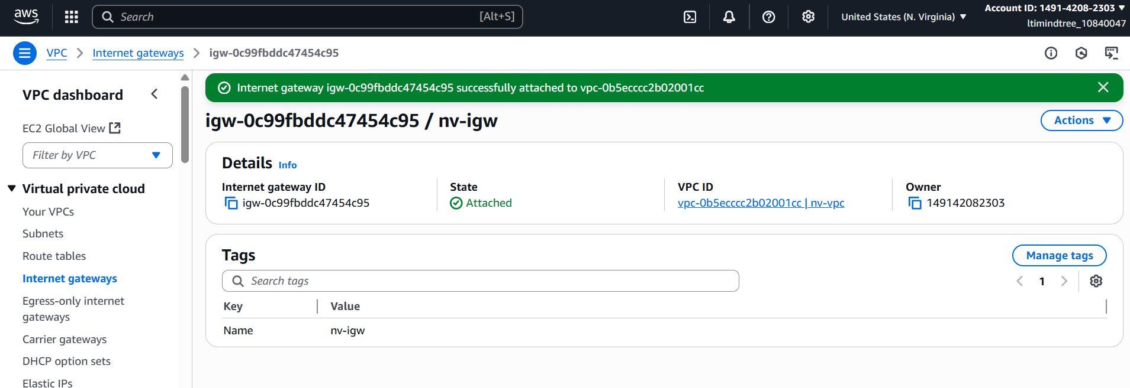

Then I created a subnet of my vpc.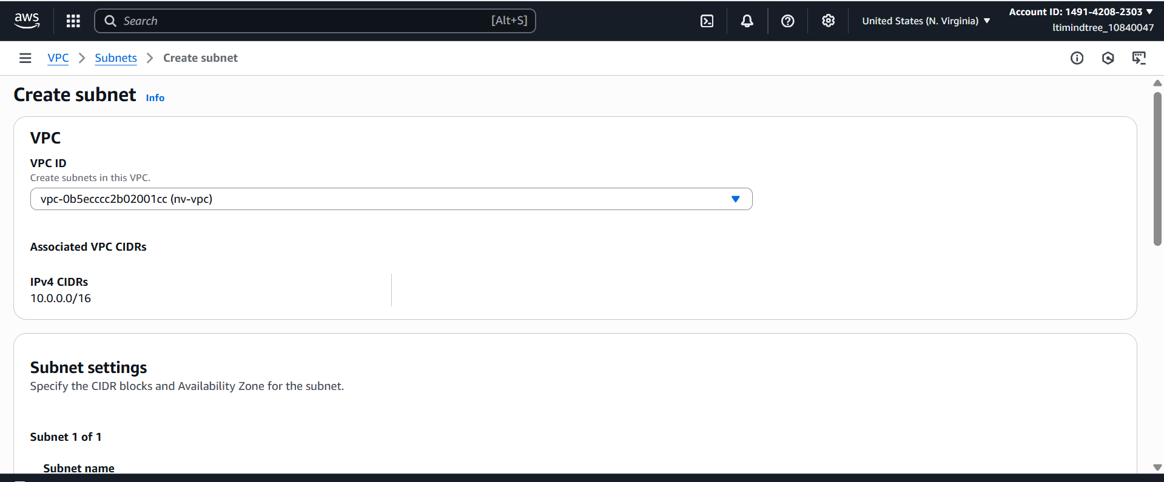

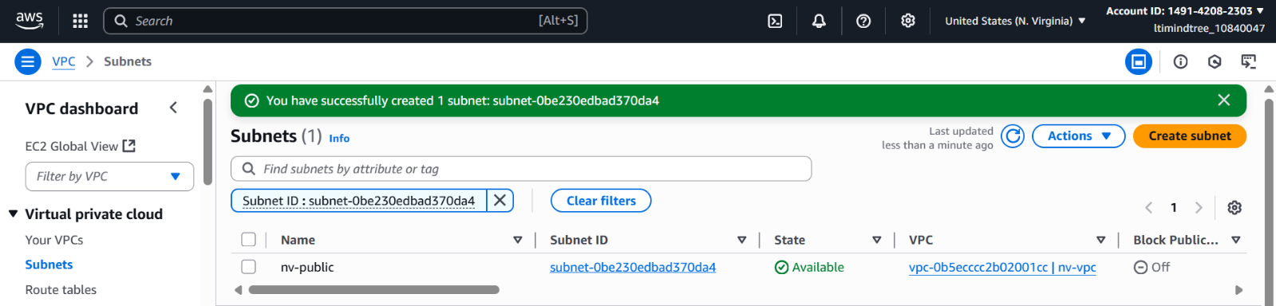

Then I created a route table 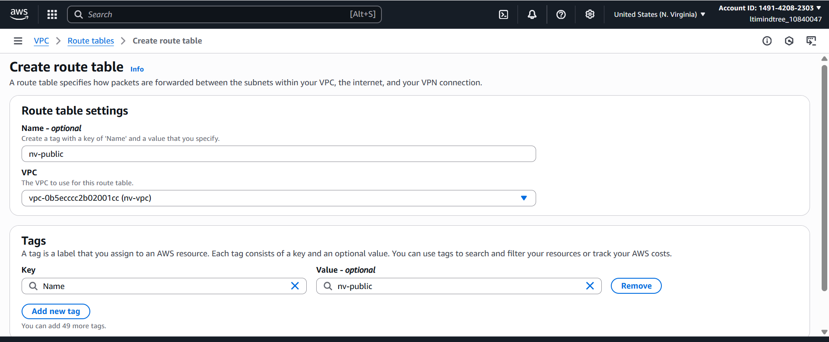 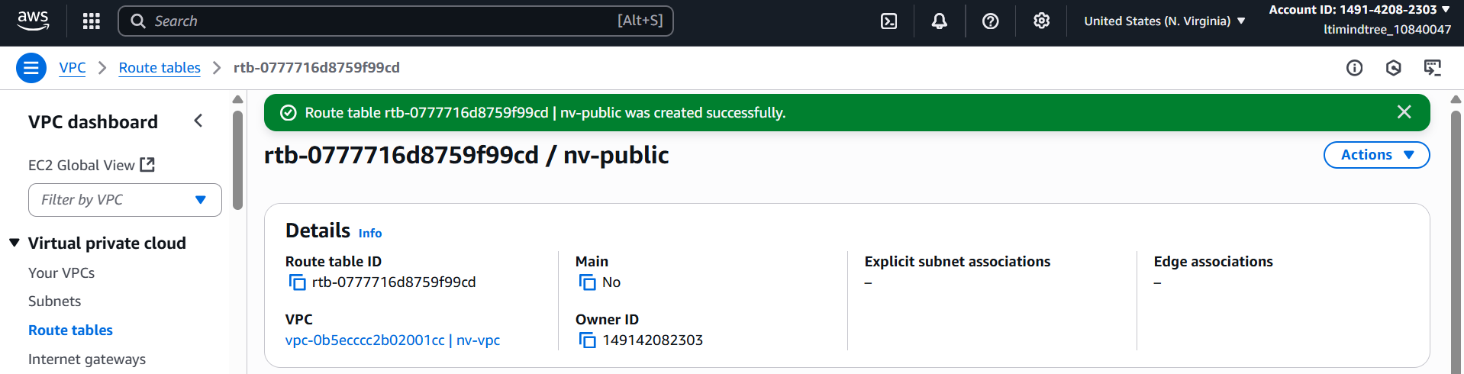

In the route table, I added the internet gateway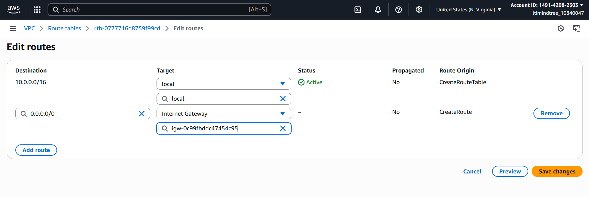

Then added the subnet association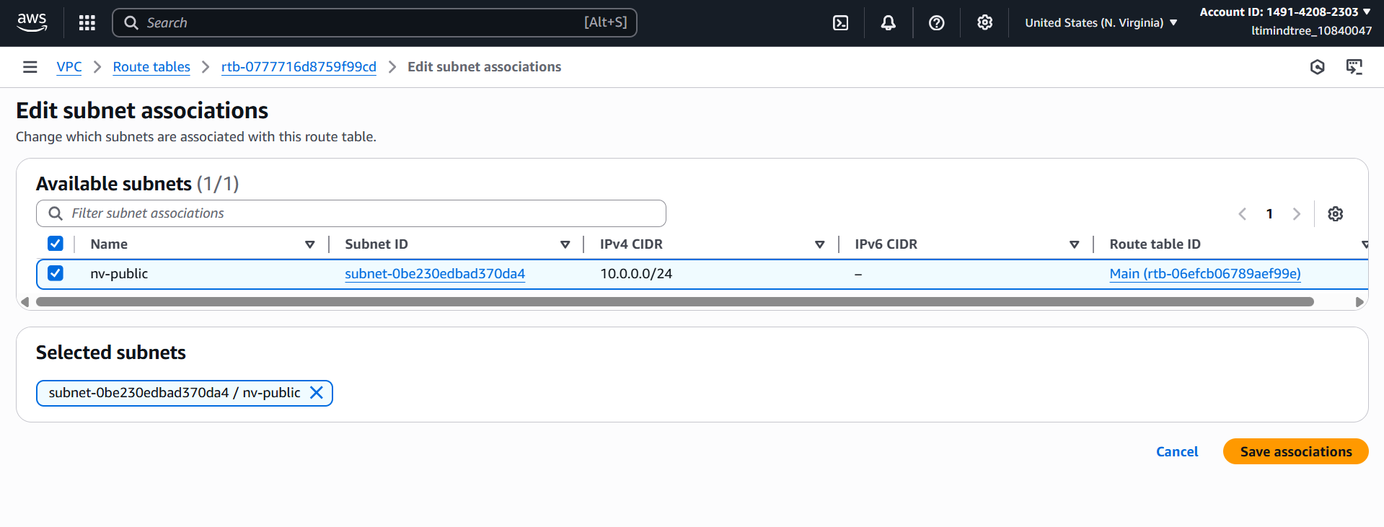 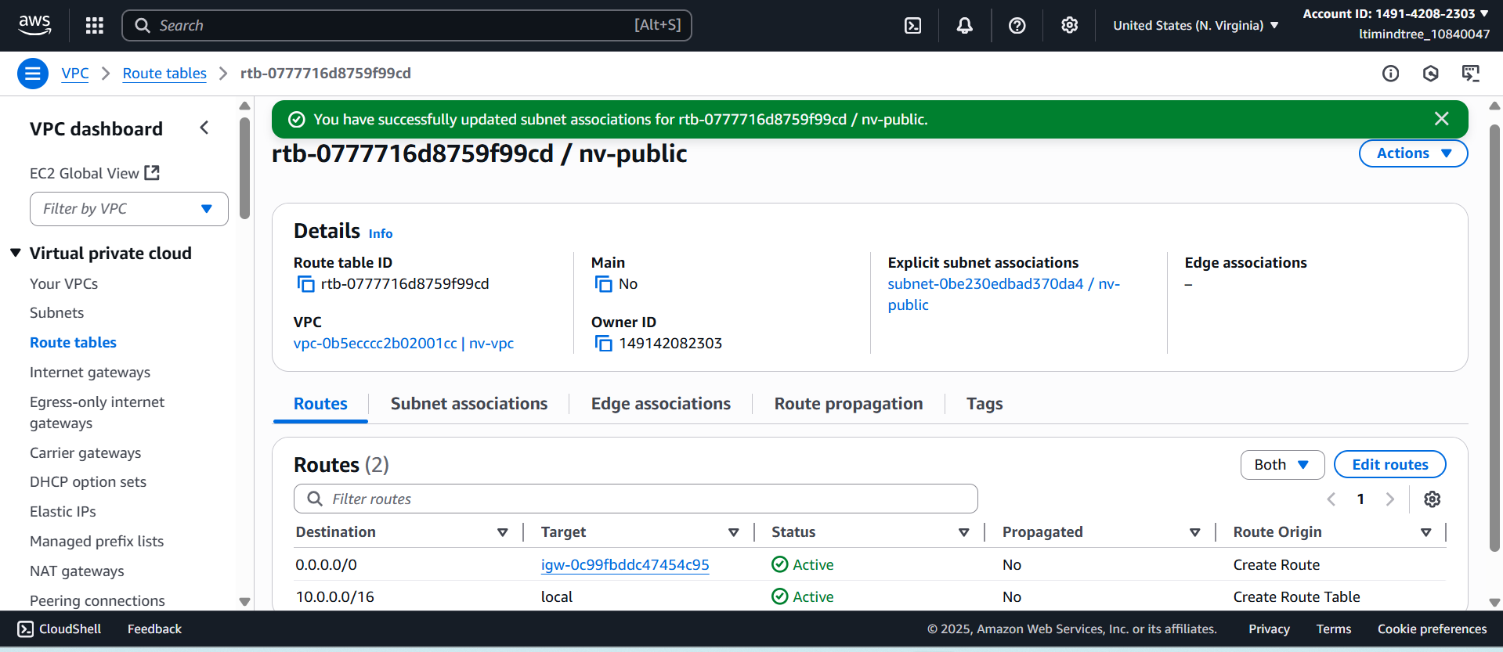

After that, I launched an instance in same North Virginia region with my vpc and subnet. 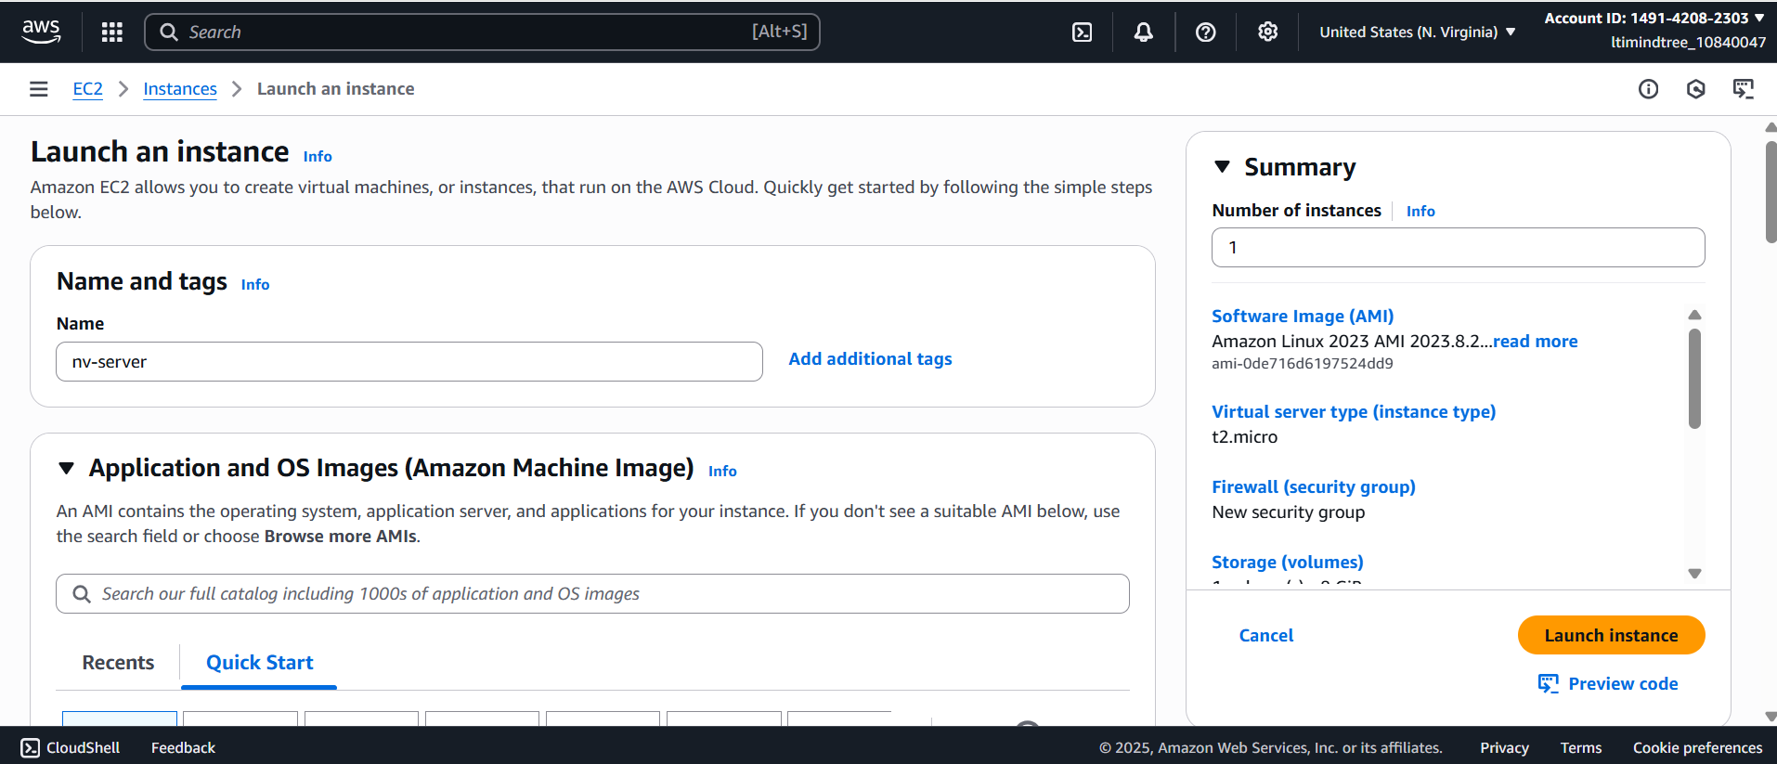 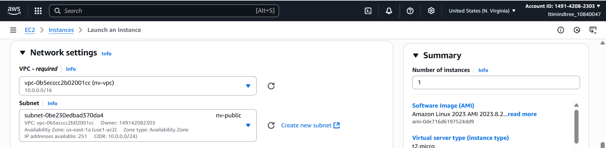

I added the port 22 and all ICMP Ipv4 in the security group.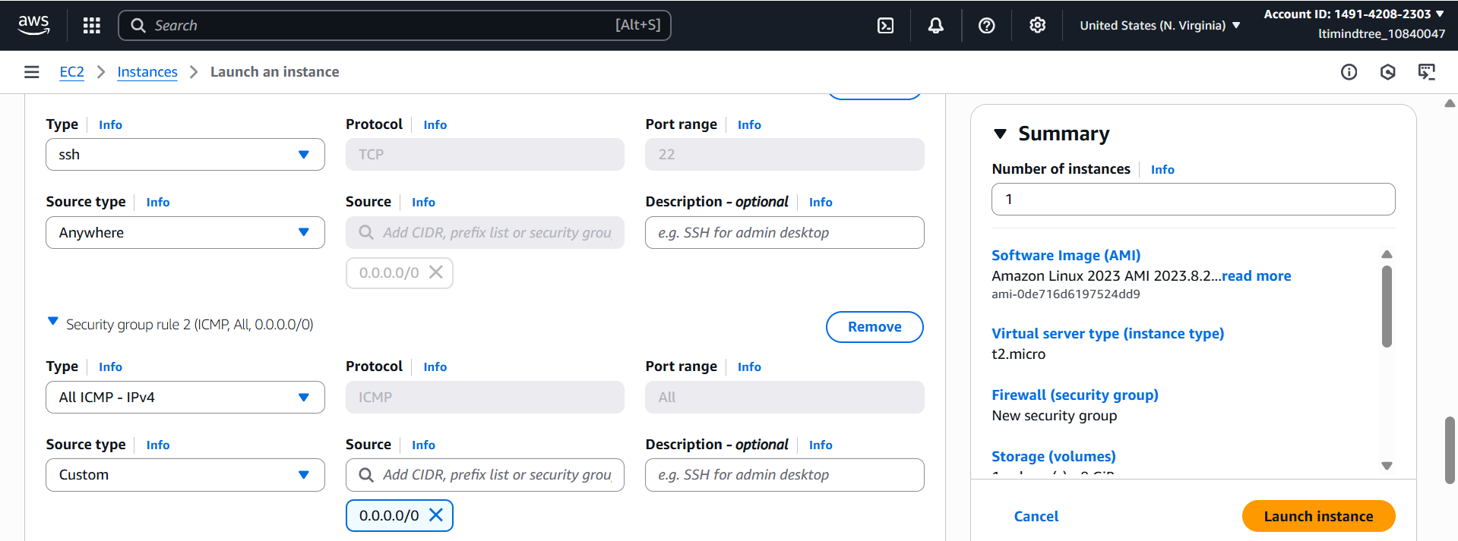 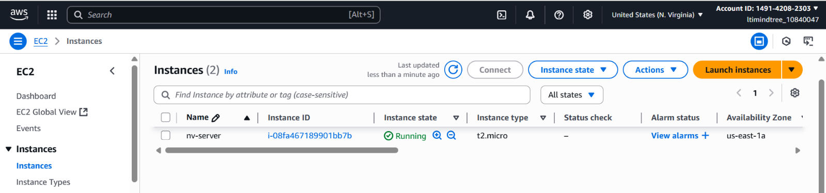

After that I did all of the above process in Ohio region too like created a vpc, internet gateway, attached the igw to vpc, then created a subnet as well as a route table and add the igw in that rout.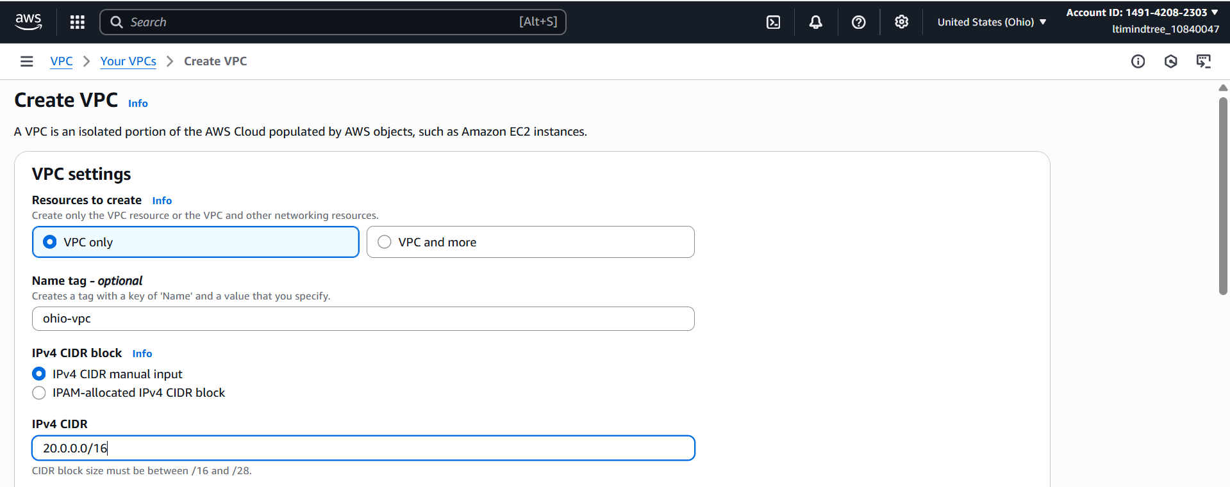 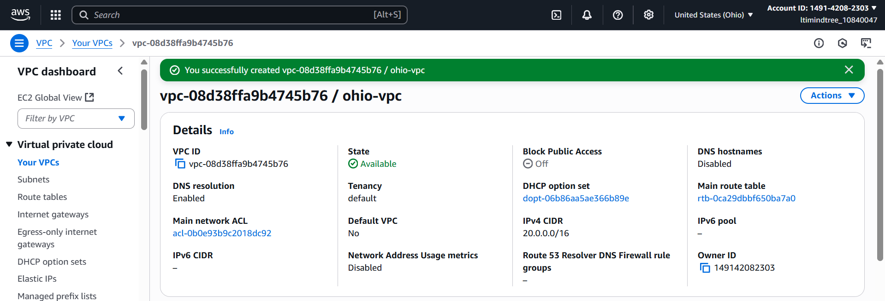 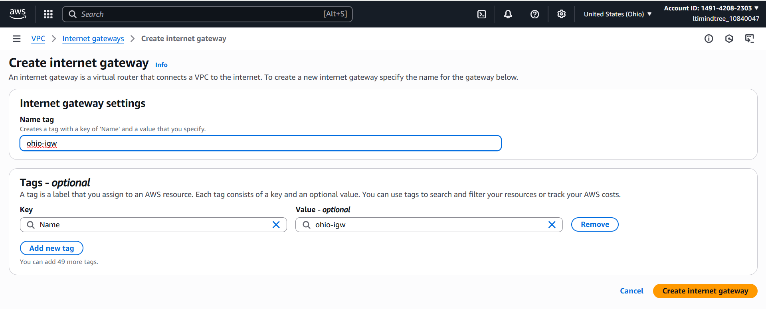 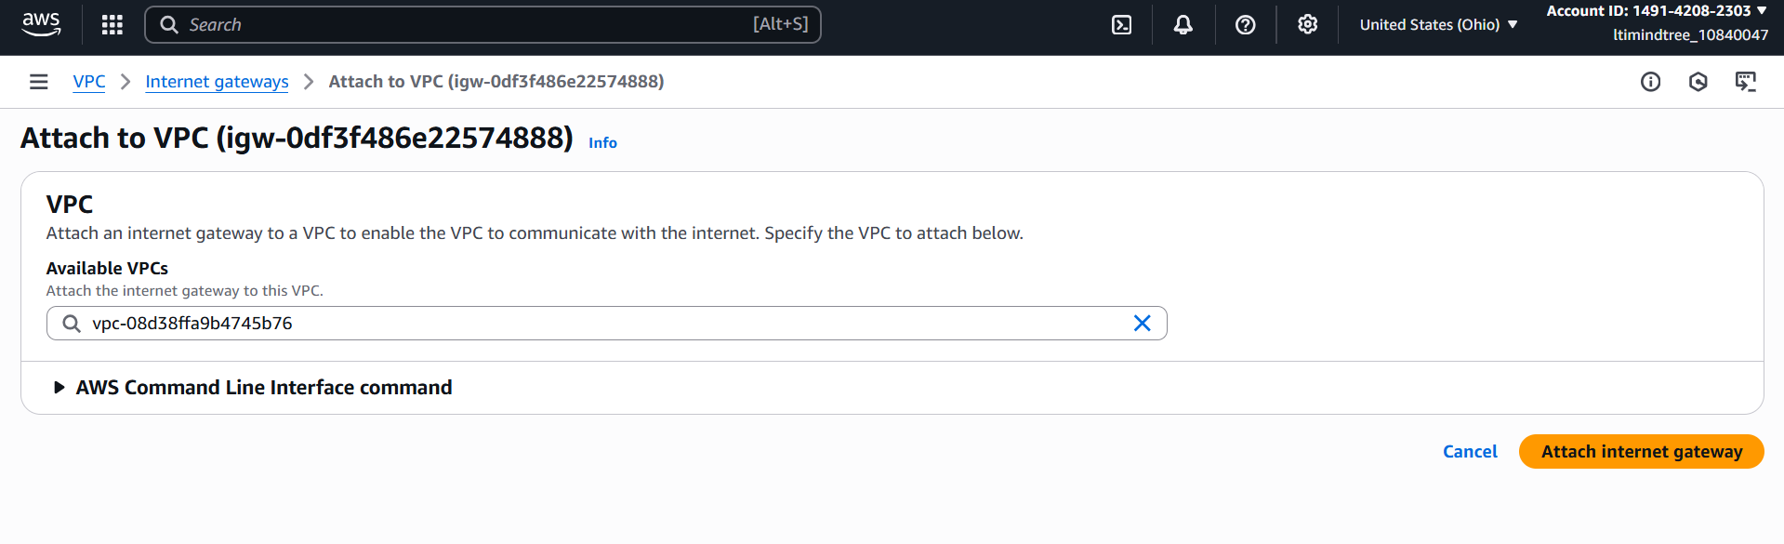 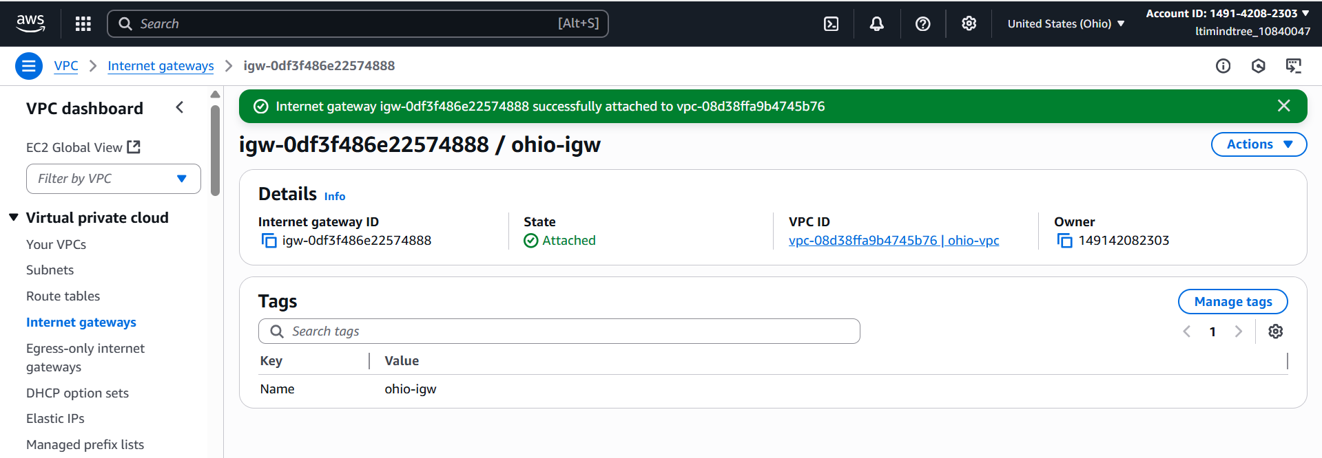 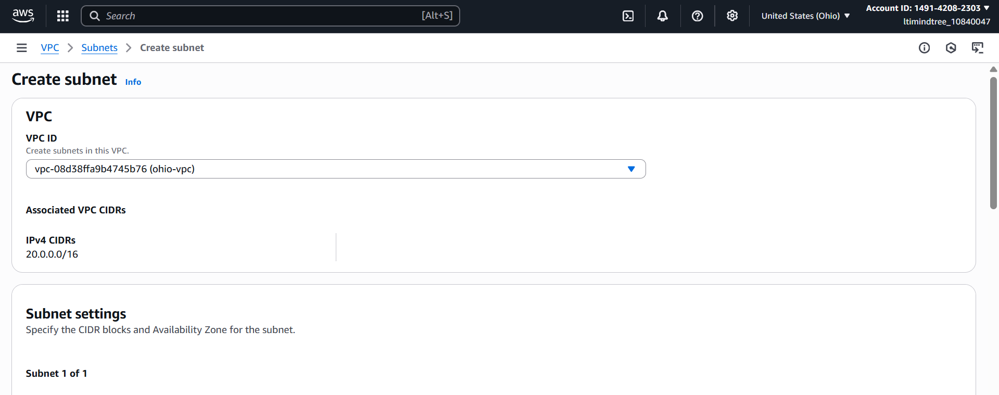 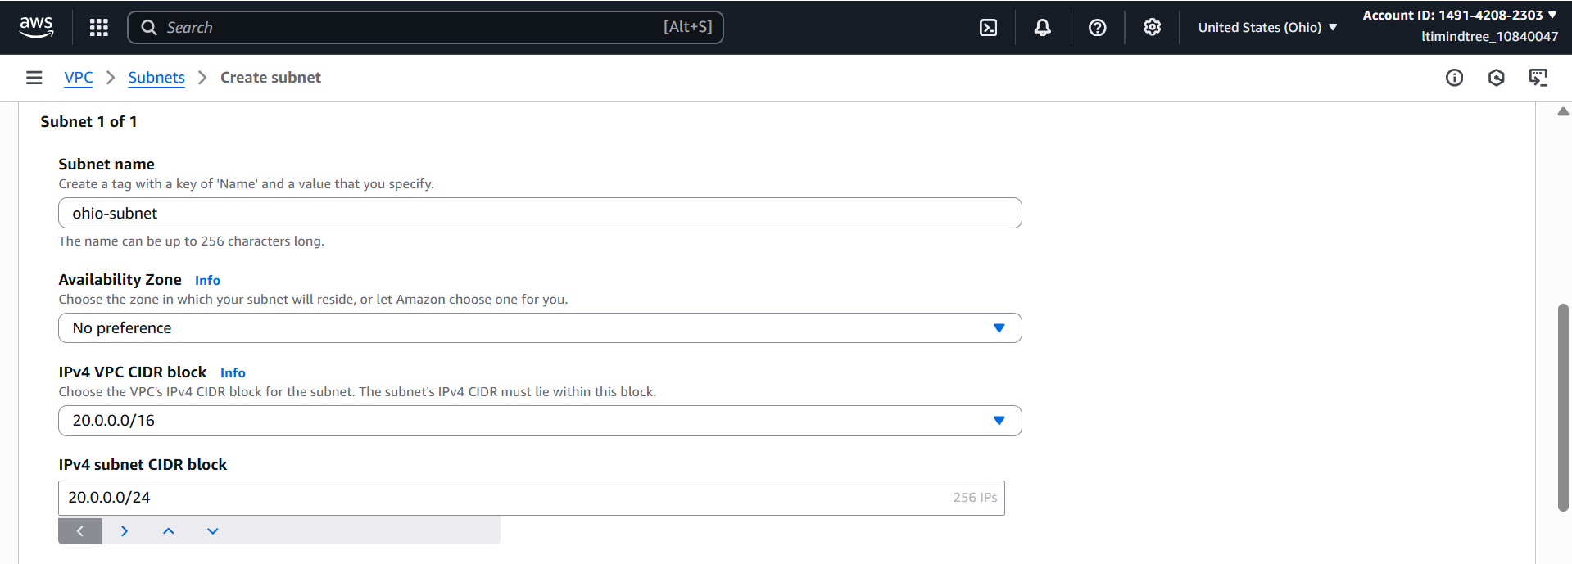 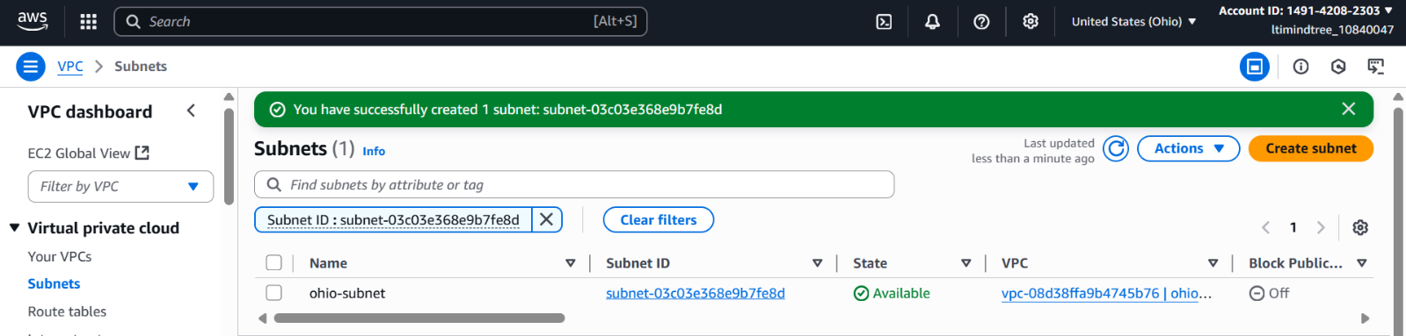 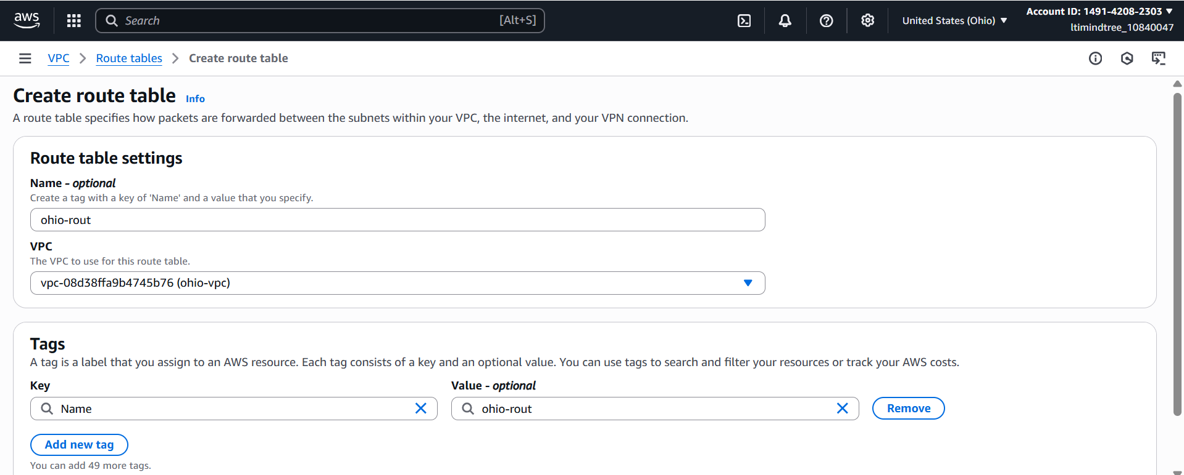 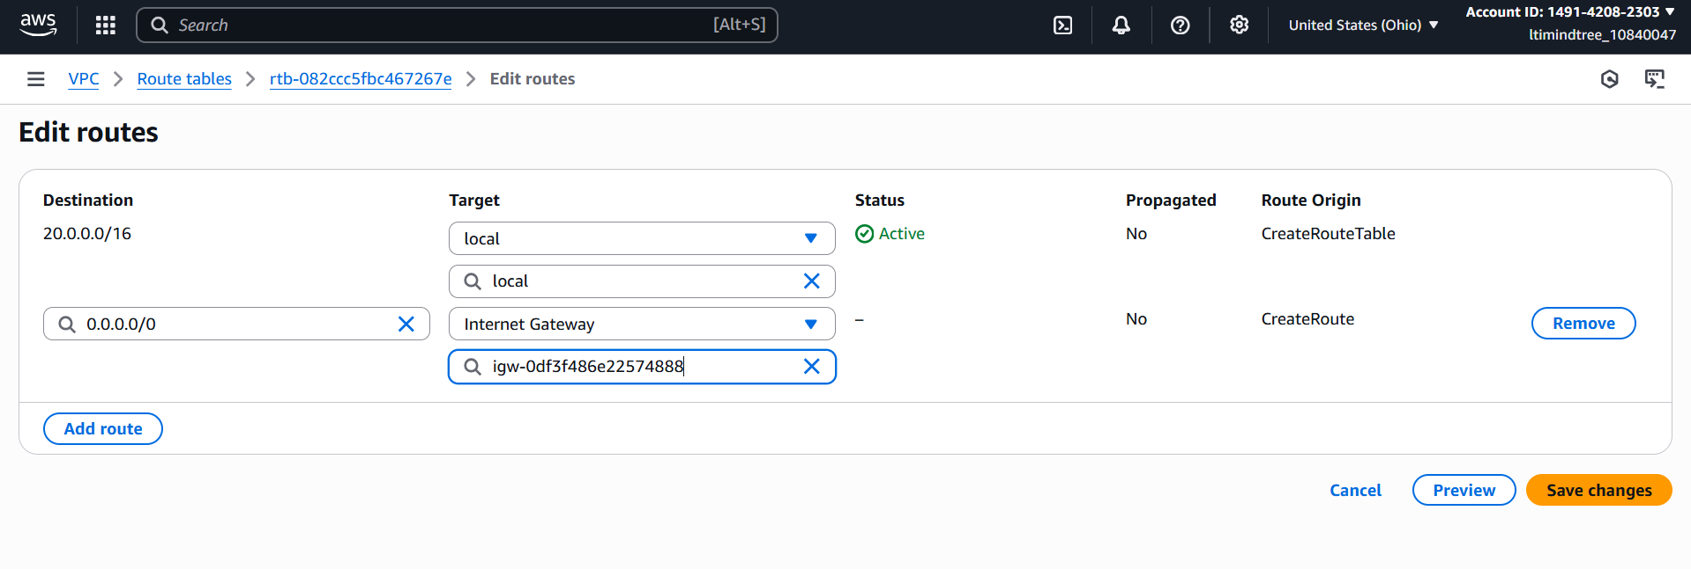 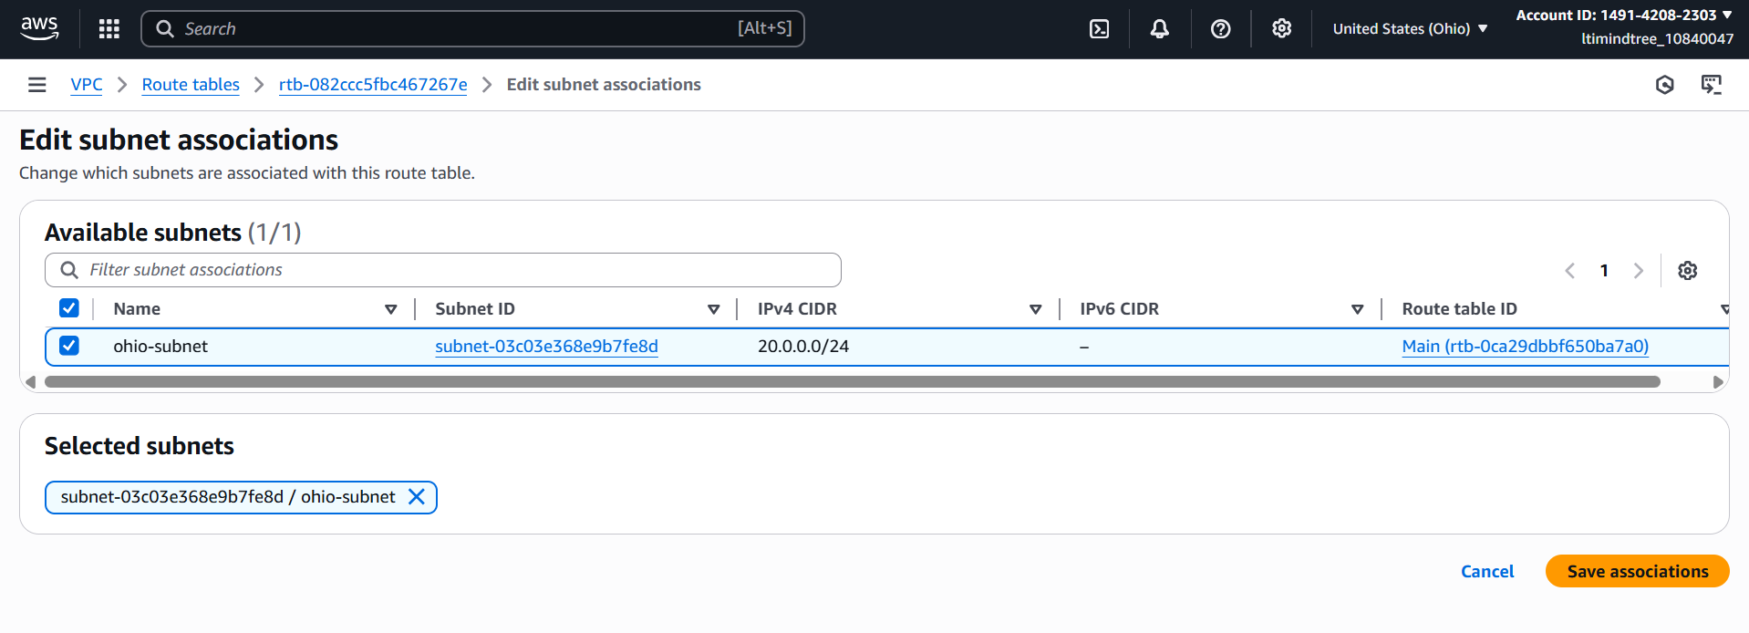 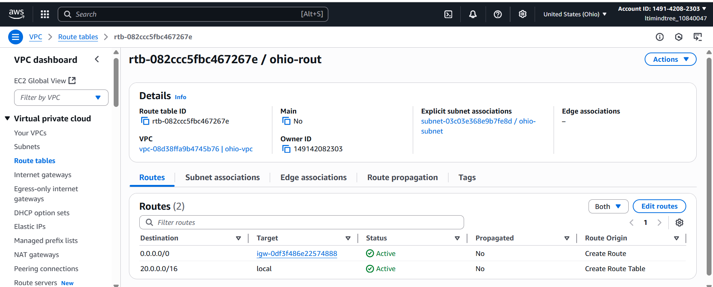

In Ohio, I also created an instance with my Ohio vpc and subnet and added ssh and ICMP ipv4 port in its security group.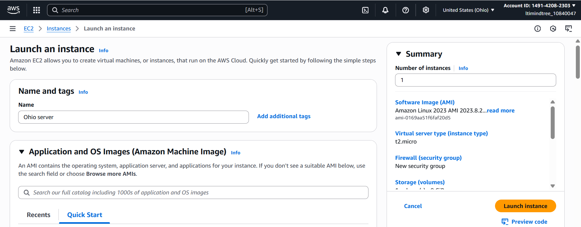 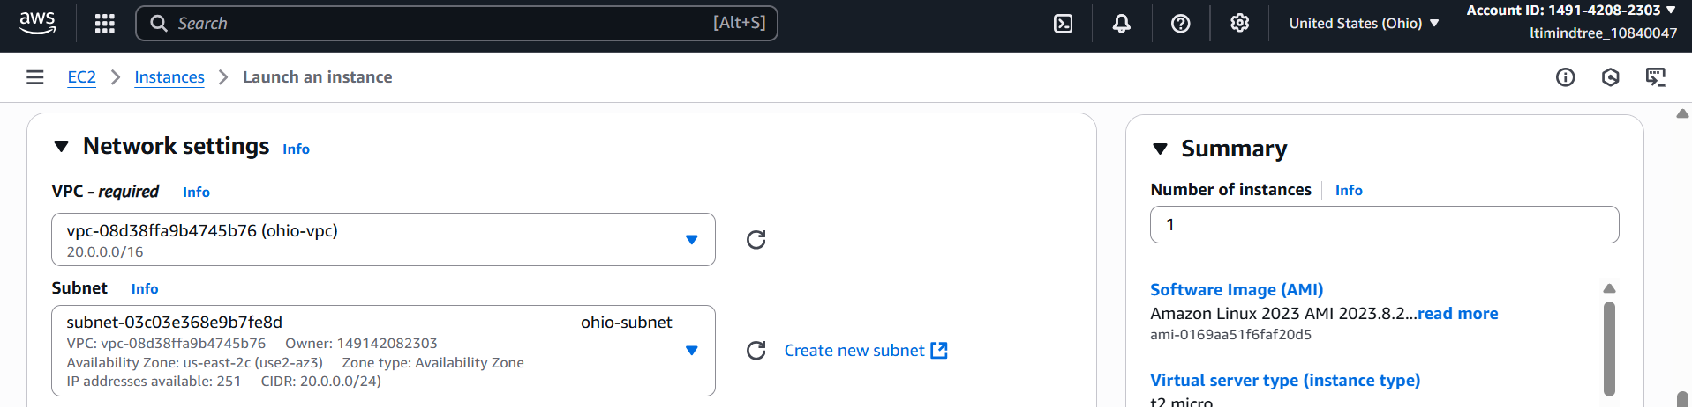 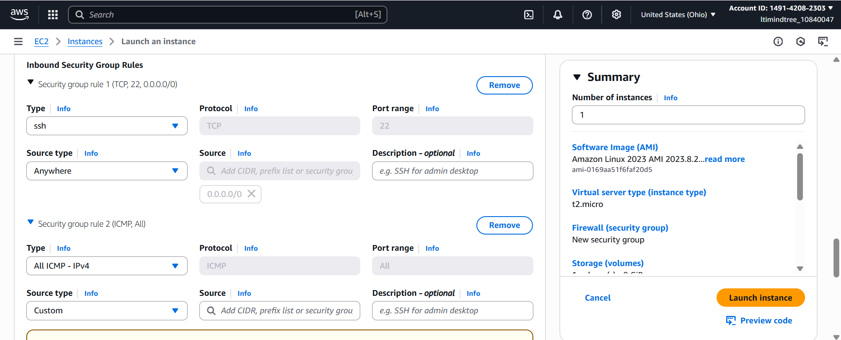 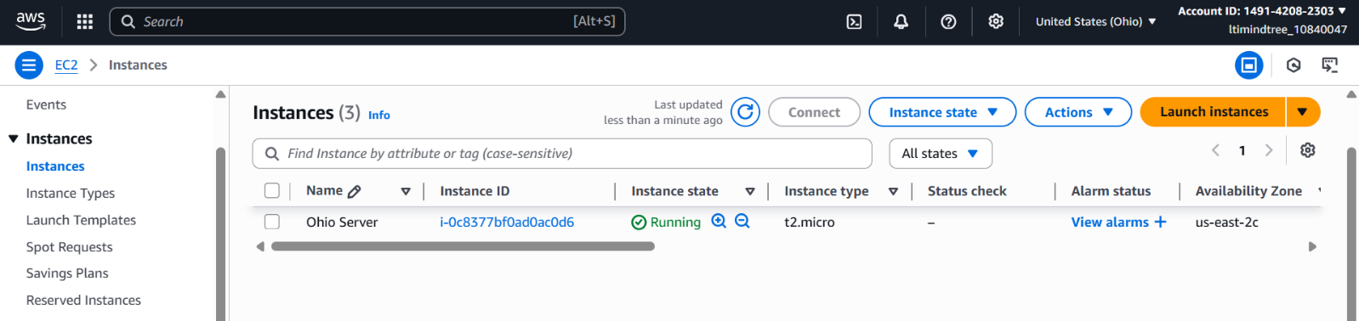

After that I created a peering connection and added the N. Virginia’s VPC ID.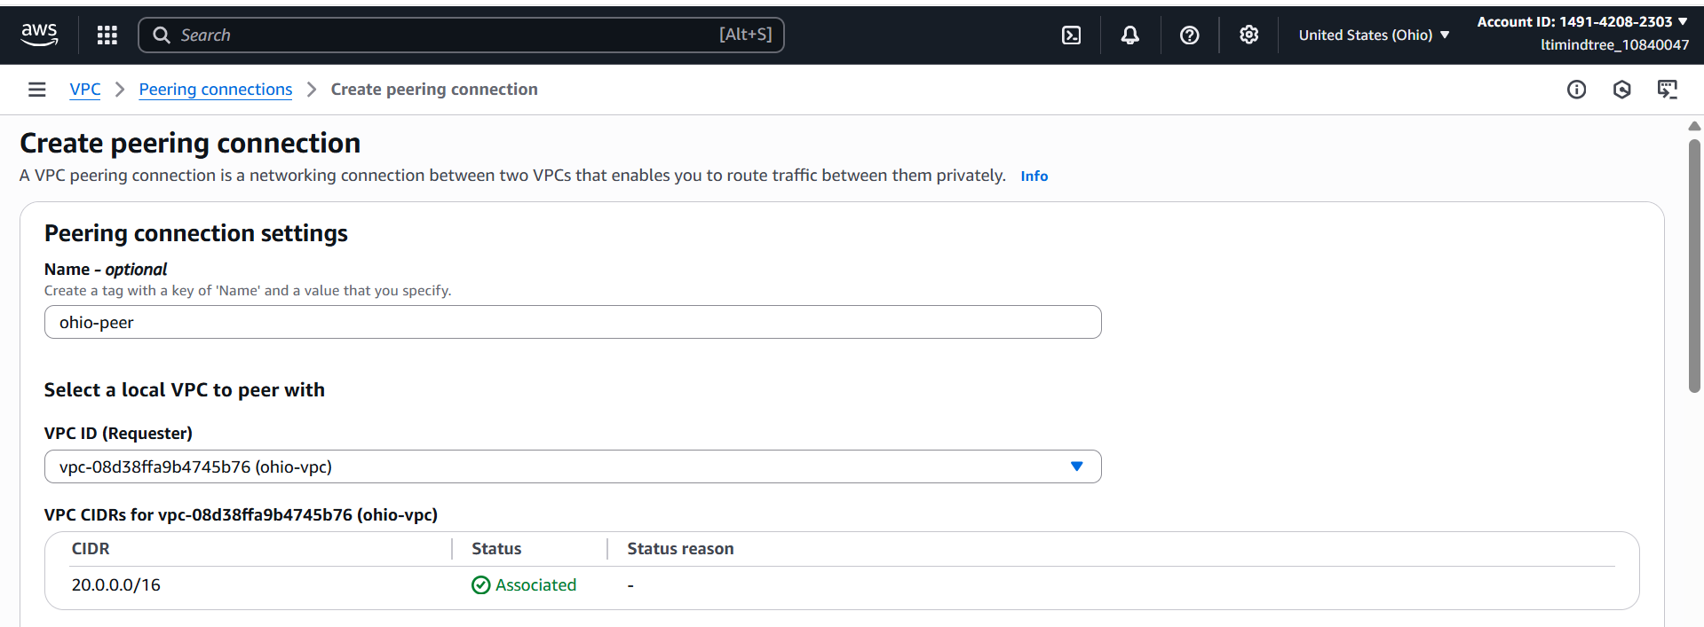 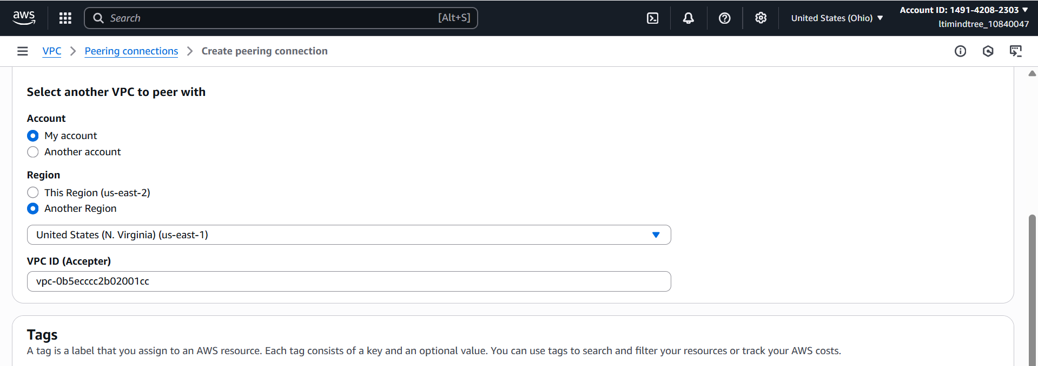 

Then I came back in N. Virginia and accepted the request.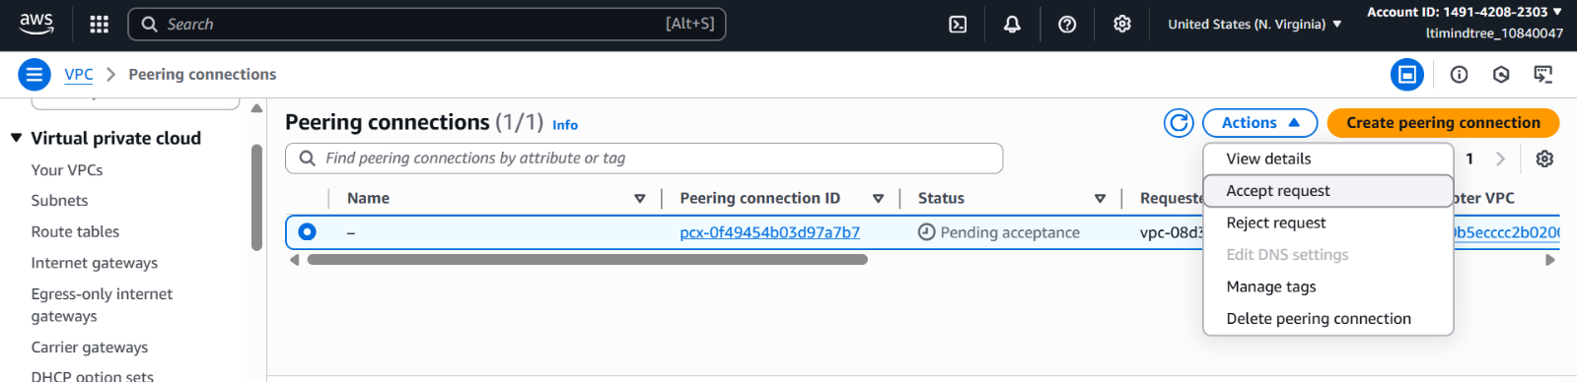 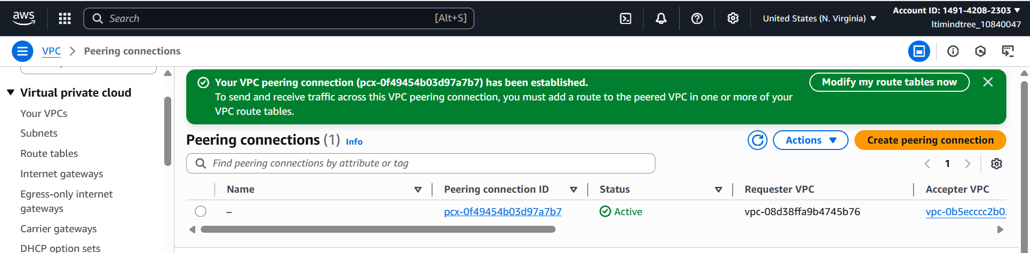

Then in the route table of both the region I added each other’s destination with target peering connection.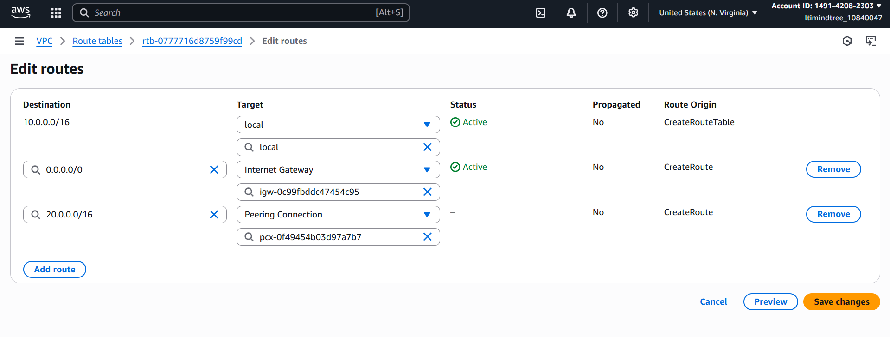 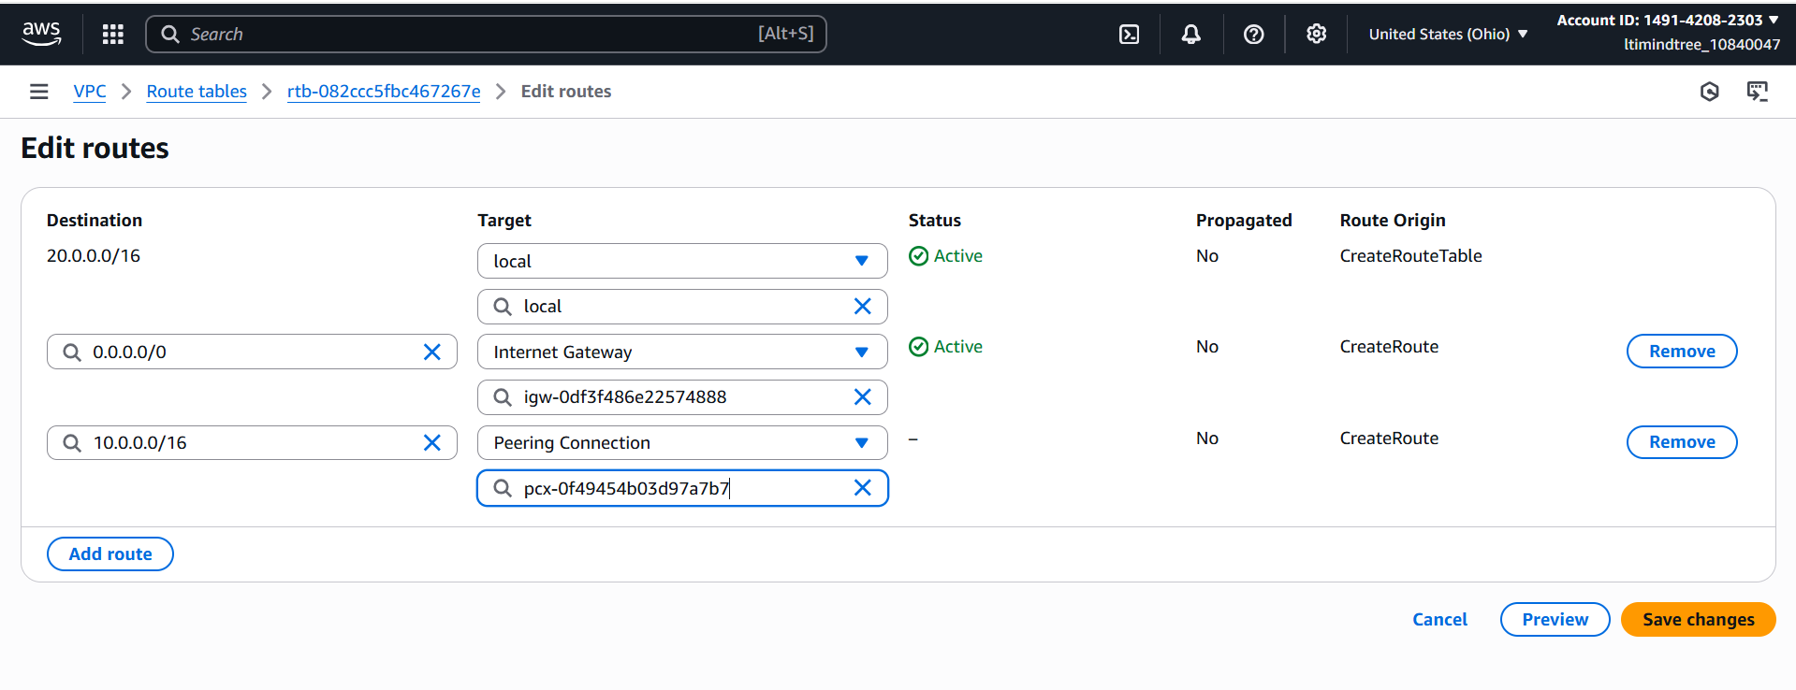

After that, I launched the N. Virginia’s instance and copied the private ip of Ohio’s instance.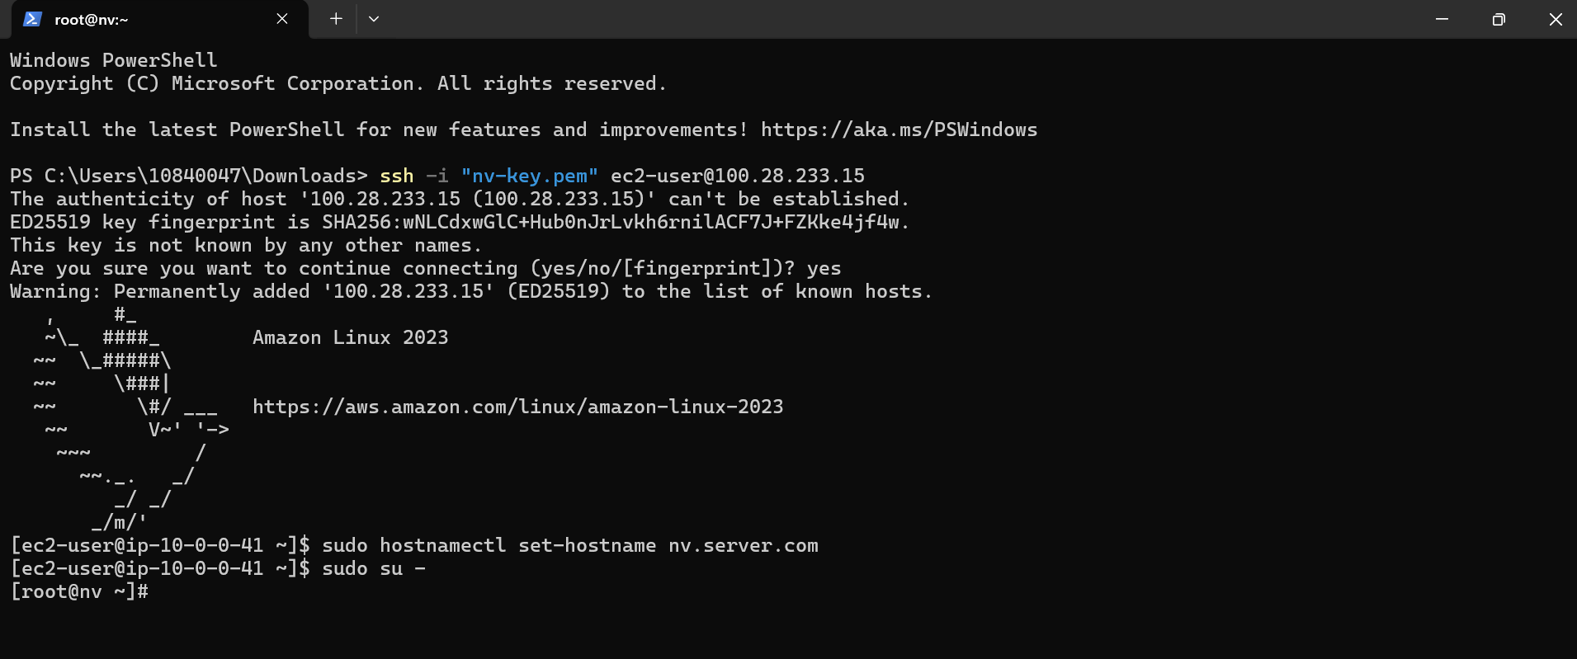

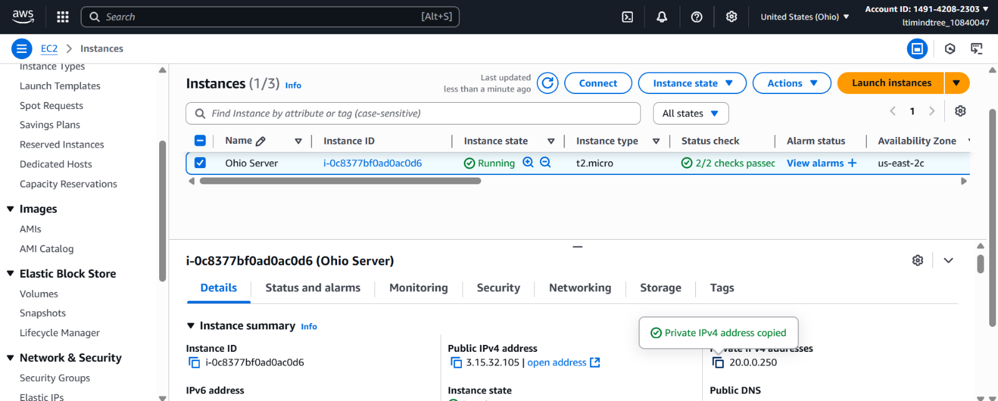

When I ran the command ***ping <Ohio’s server private ip>,*** it was working. That means the peering connection has been established.

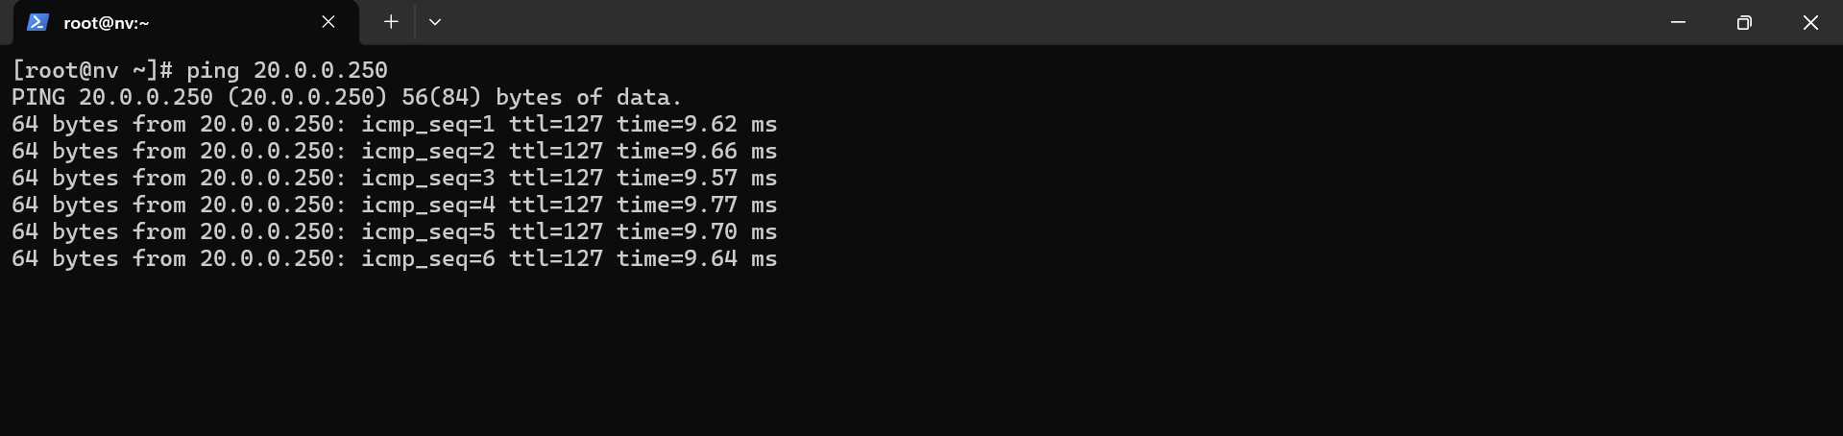

**Create a Custom VPC. Where you need to create two subnets like Private subnet and Public subnet.in the public subnet I want to host my web server. Where my website is running and Private subnet my database is running. Data base should not be reachable publicly.**

At first, I created a vpc, then an internet gateway and attached it to the vpc.

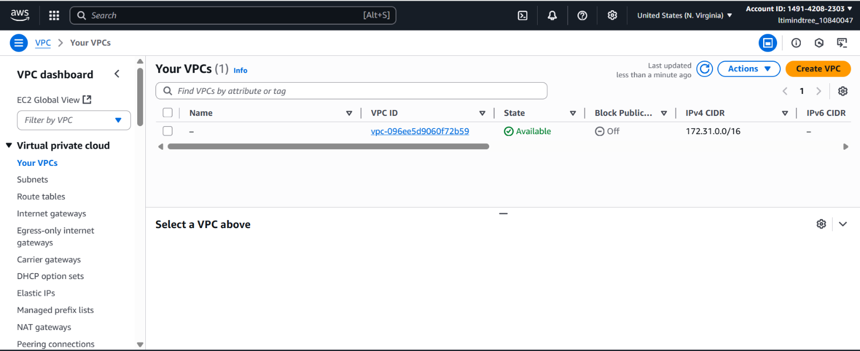 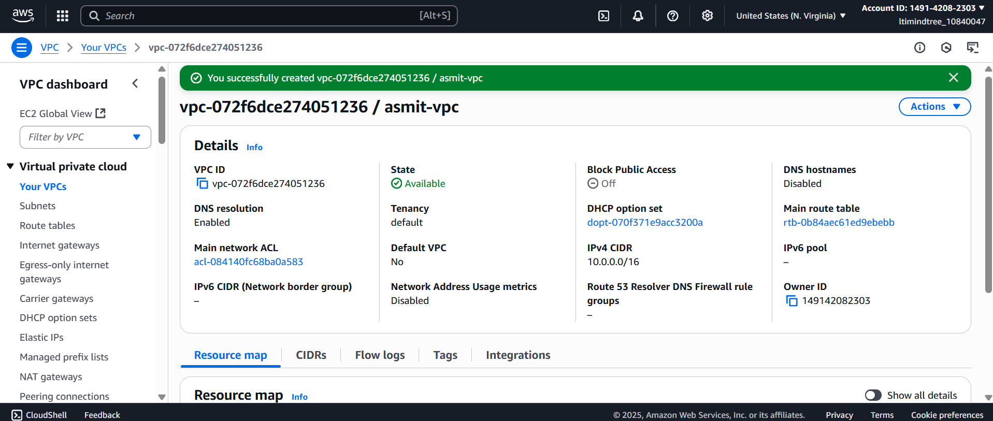 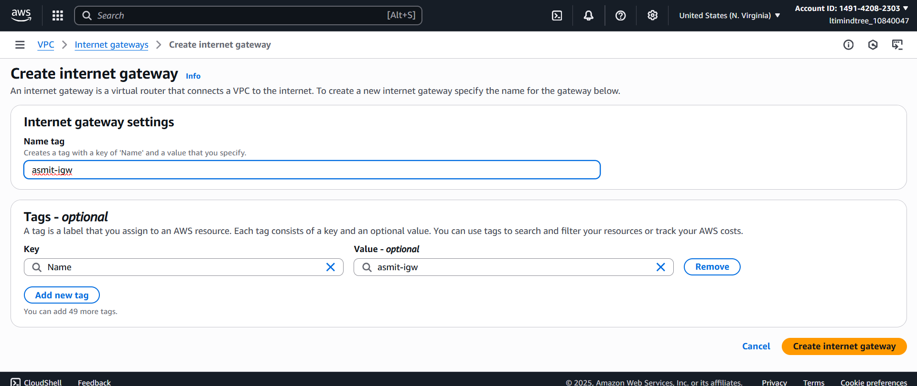 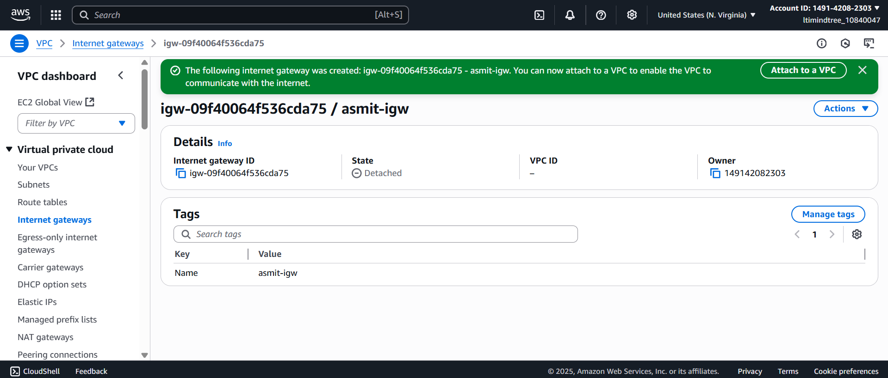 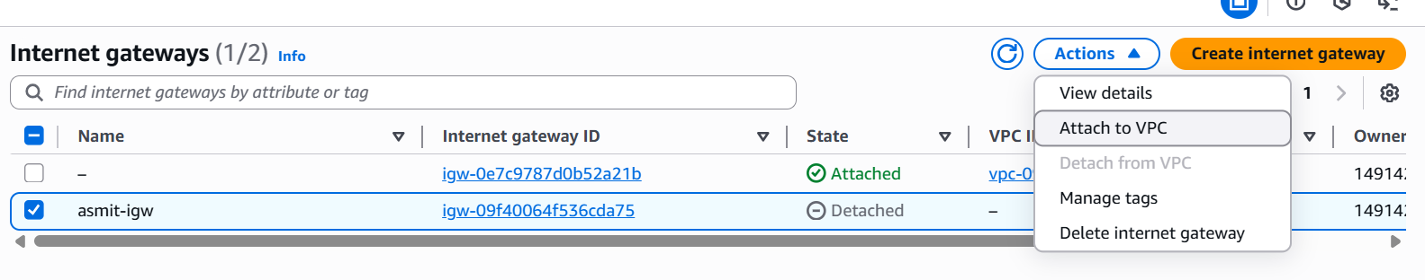 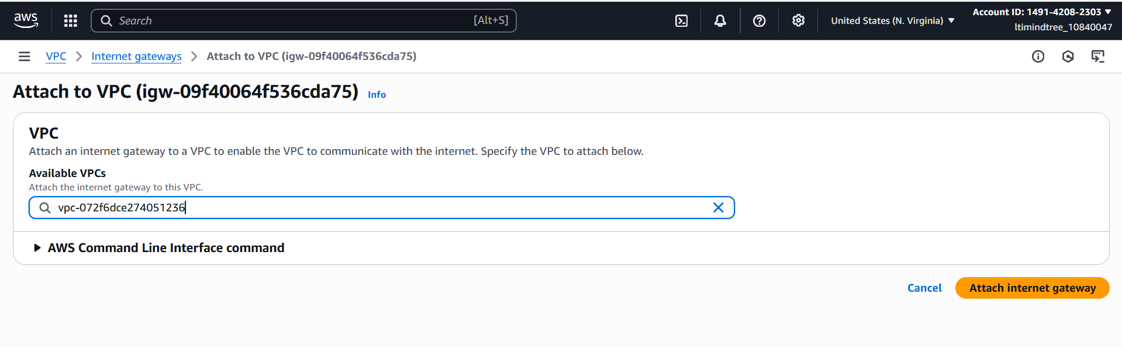 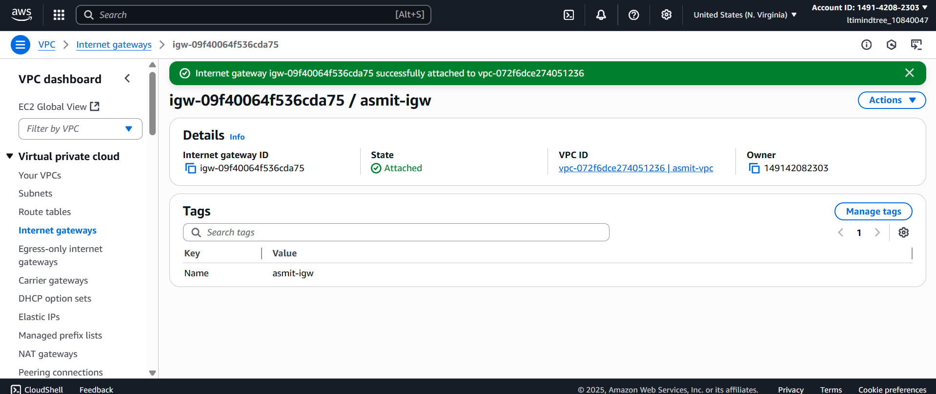

Then I created two subnets, one is public and another is private.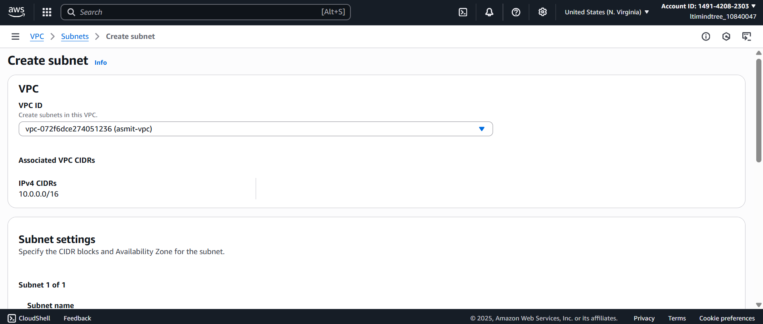 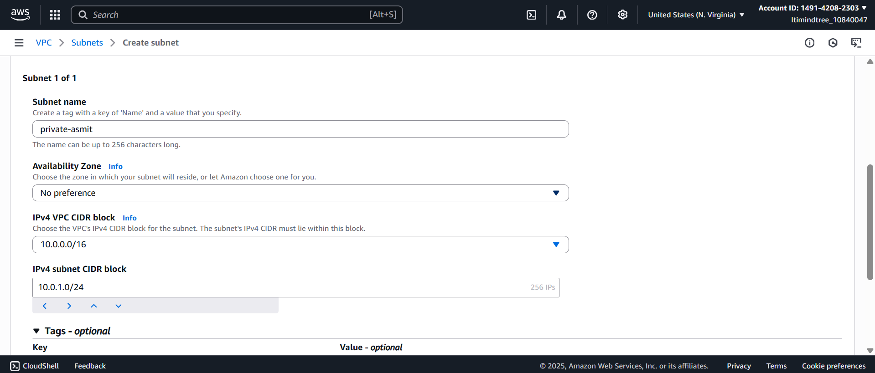 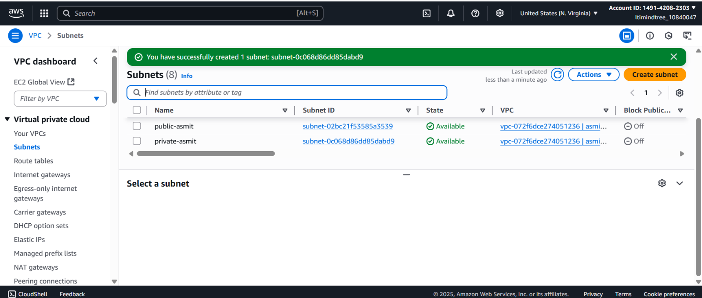

Then I created a route table and added the target internet gateway to it. Also I added subnet association with public subnet in the route table. 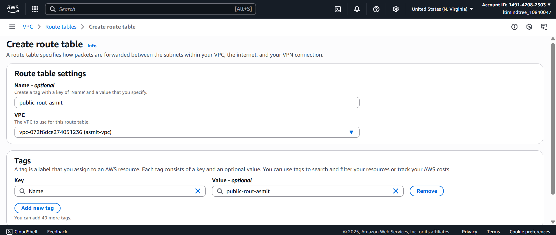 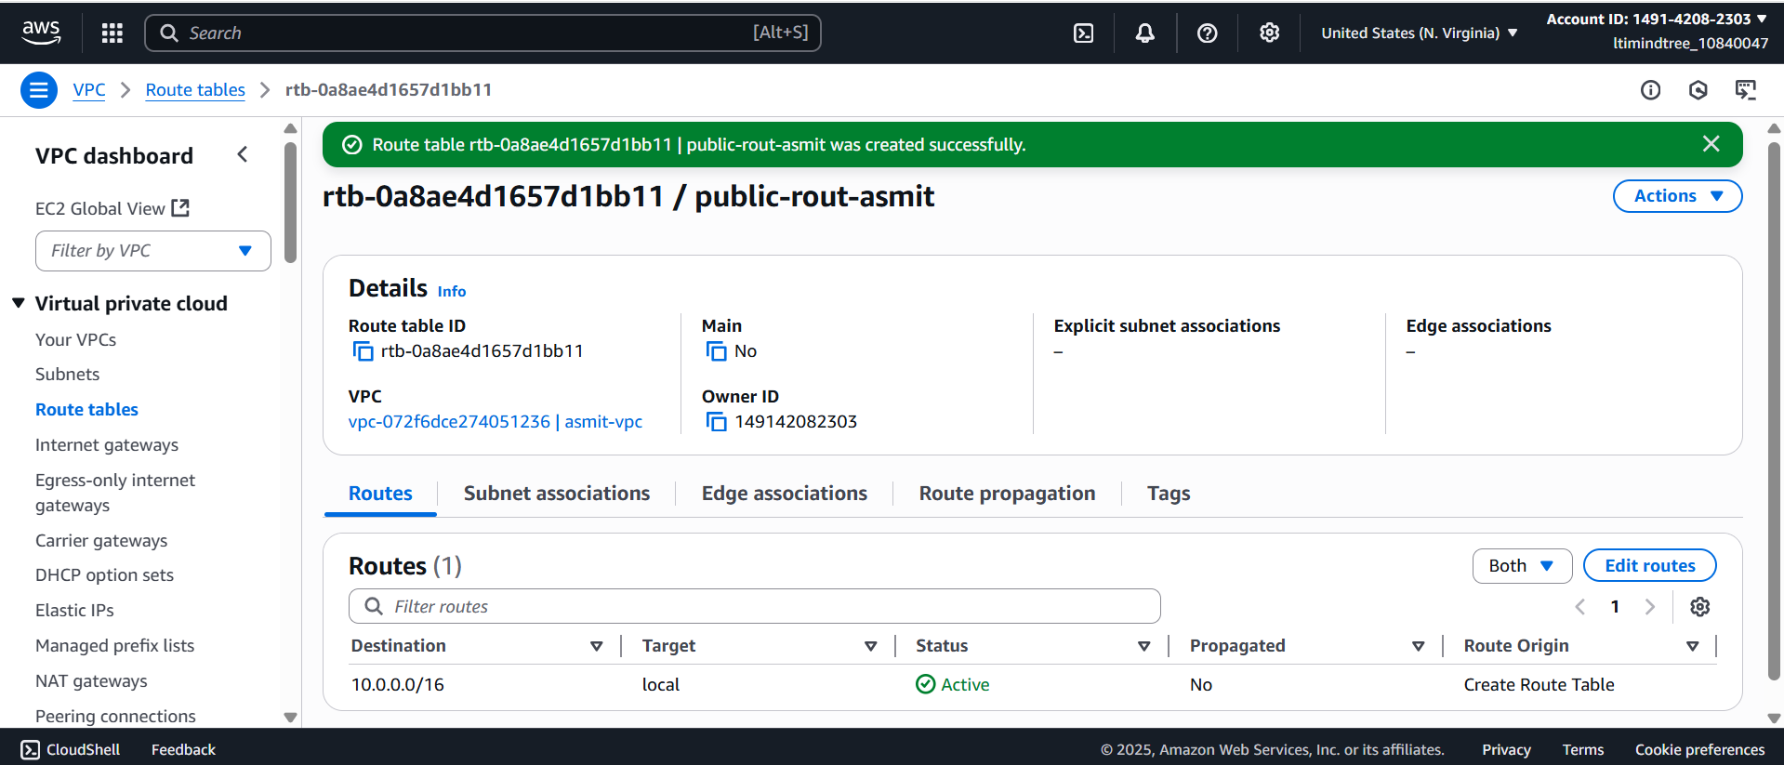 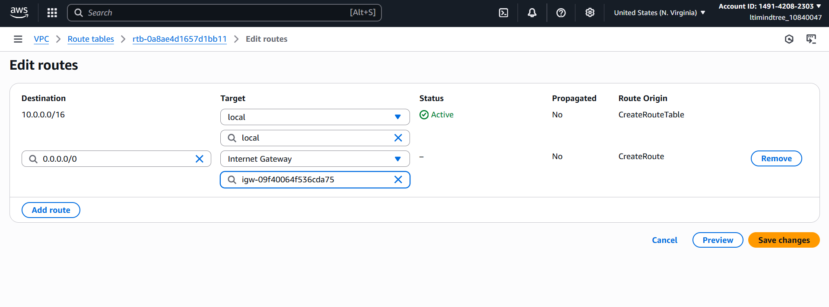 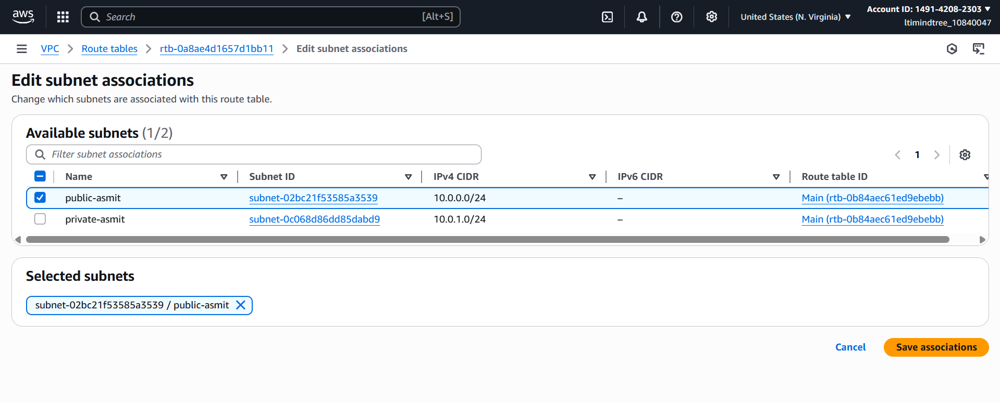

After that, I launched an instance ***Web Server*** using my custom vpc and public subnet with port ssh and ICMP ipv4 in the security group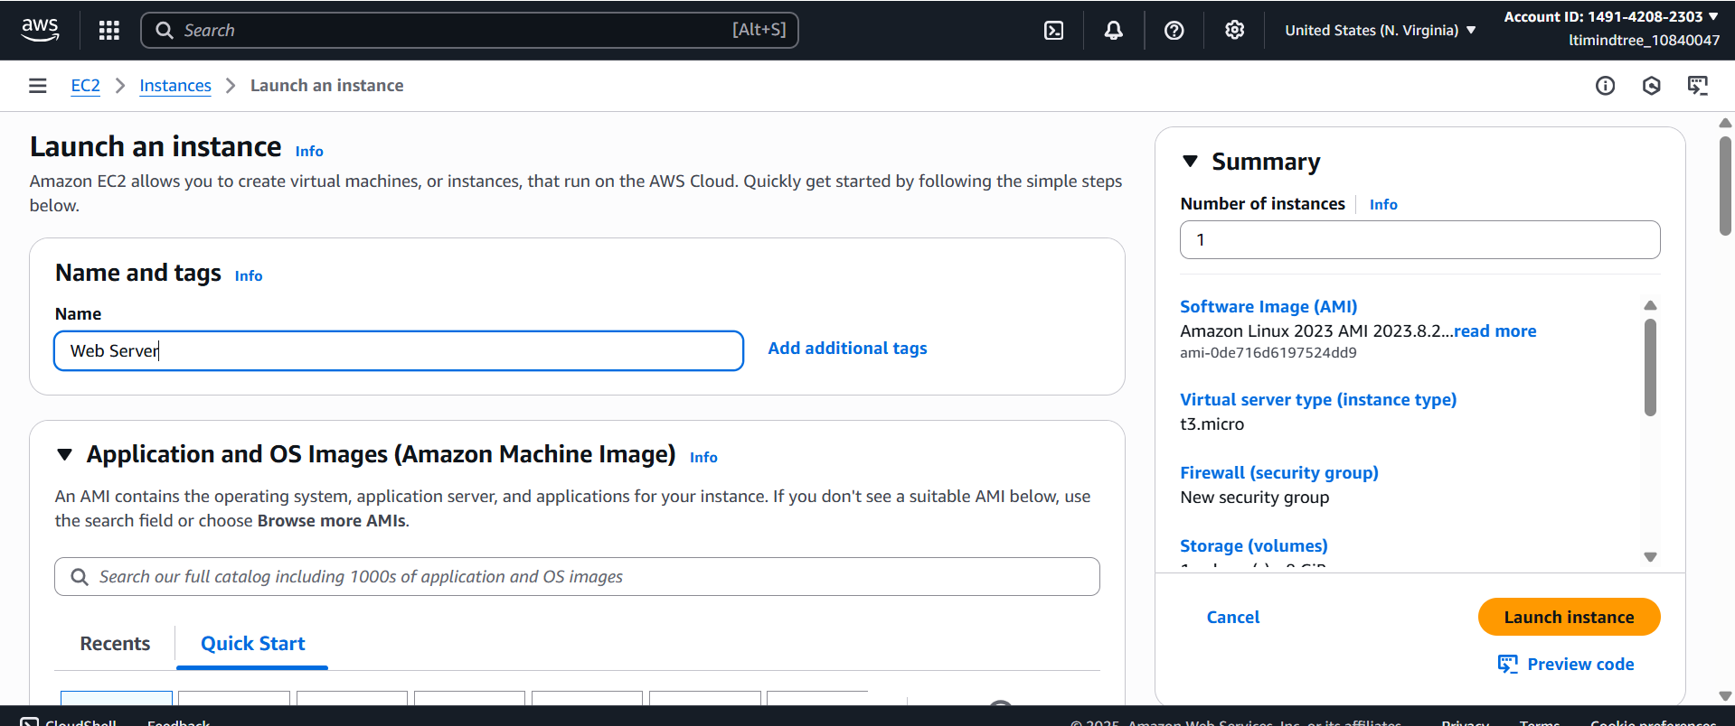 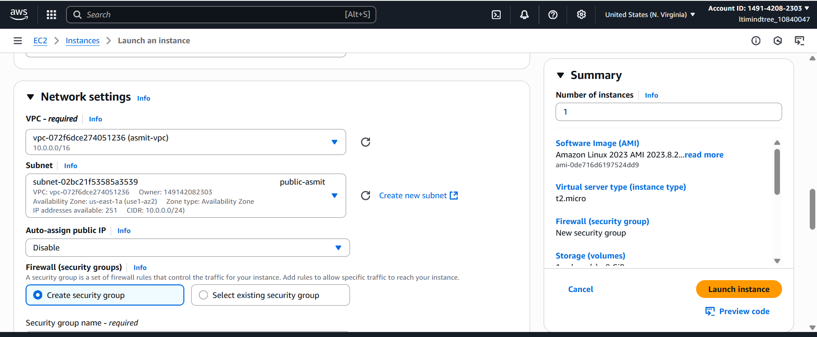 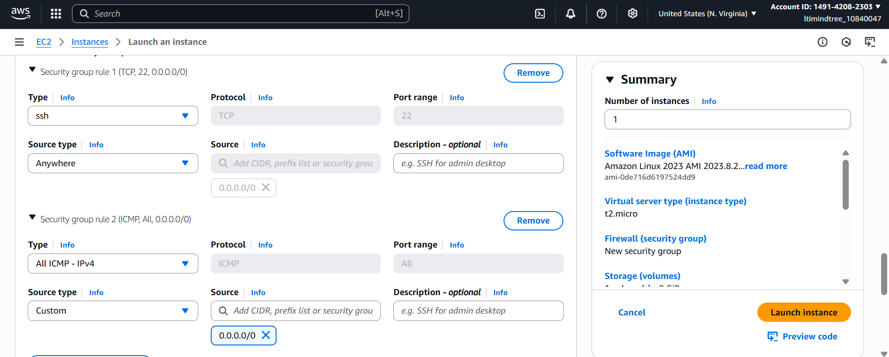

I launched another instance ***Database Server***  with the custom vpc and private subnet with port ssh and ICMP ipv4 in the security group.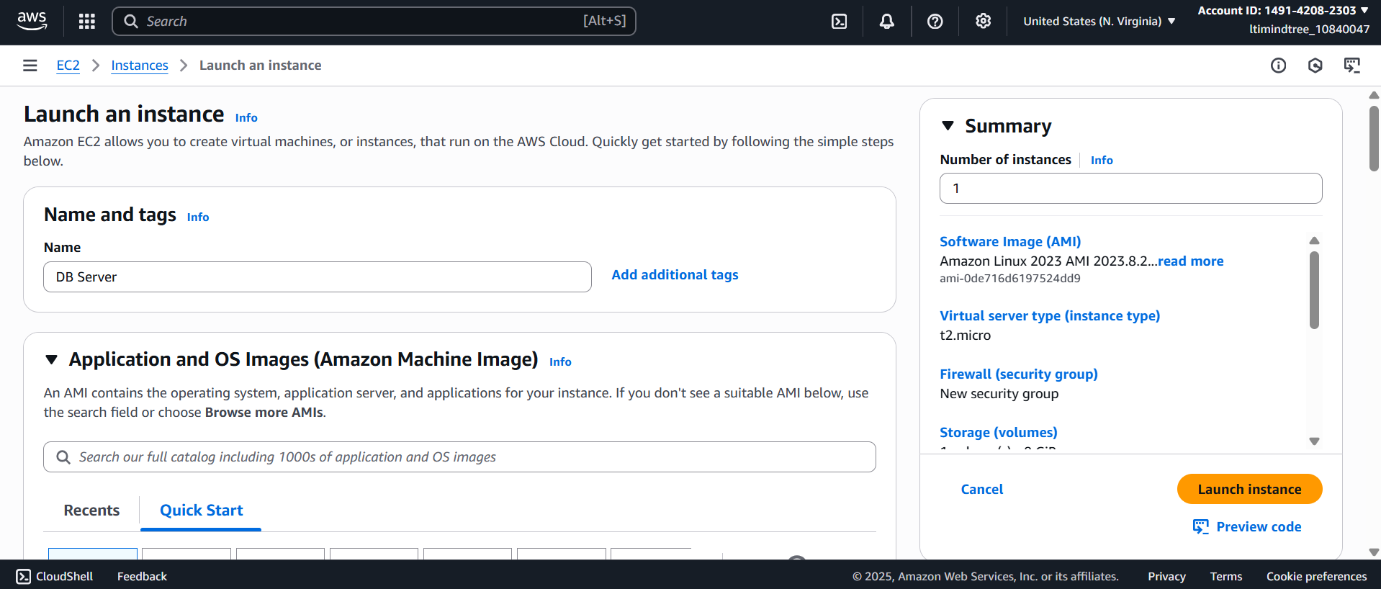 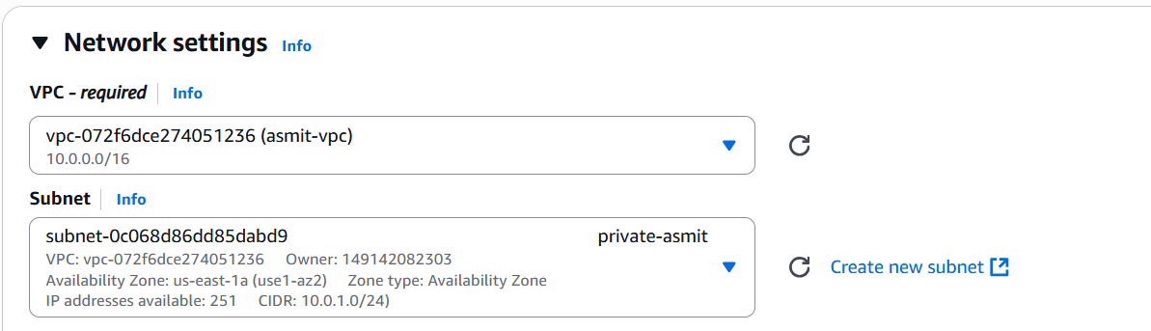 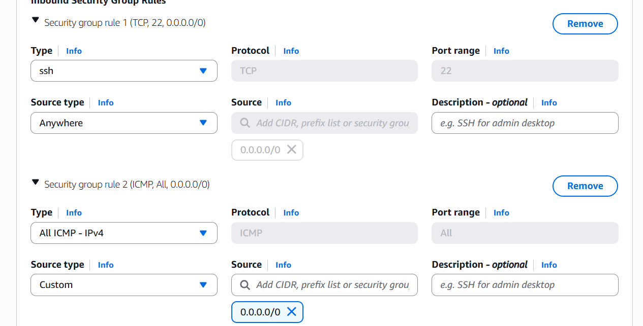 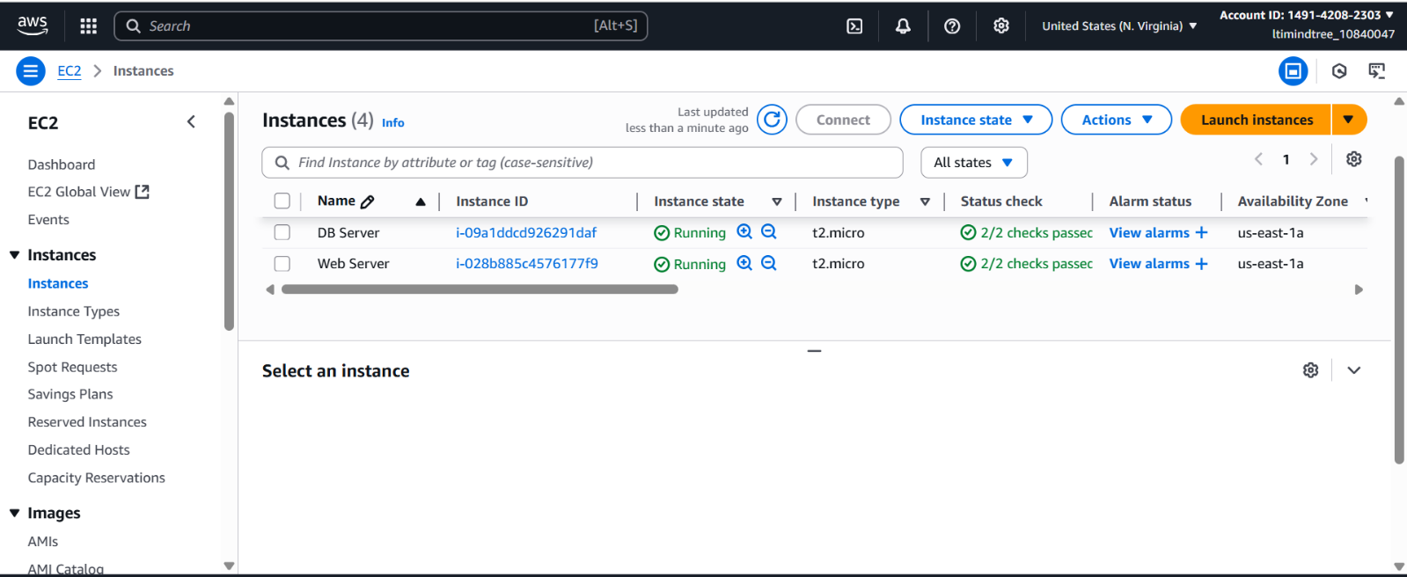

Then I launched the web server in the terminal. 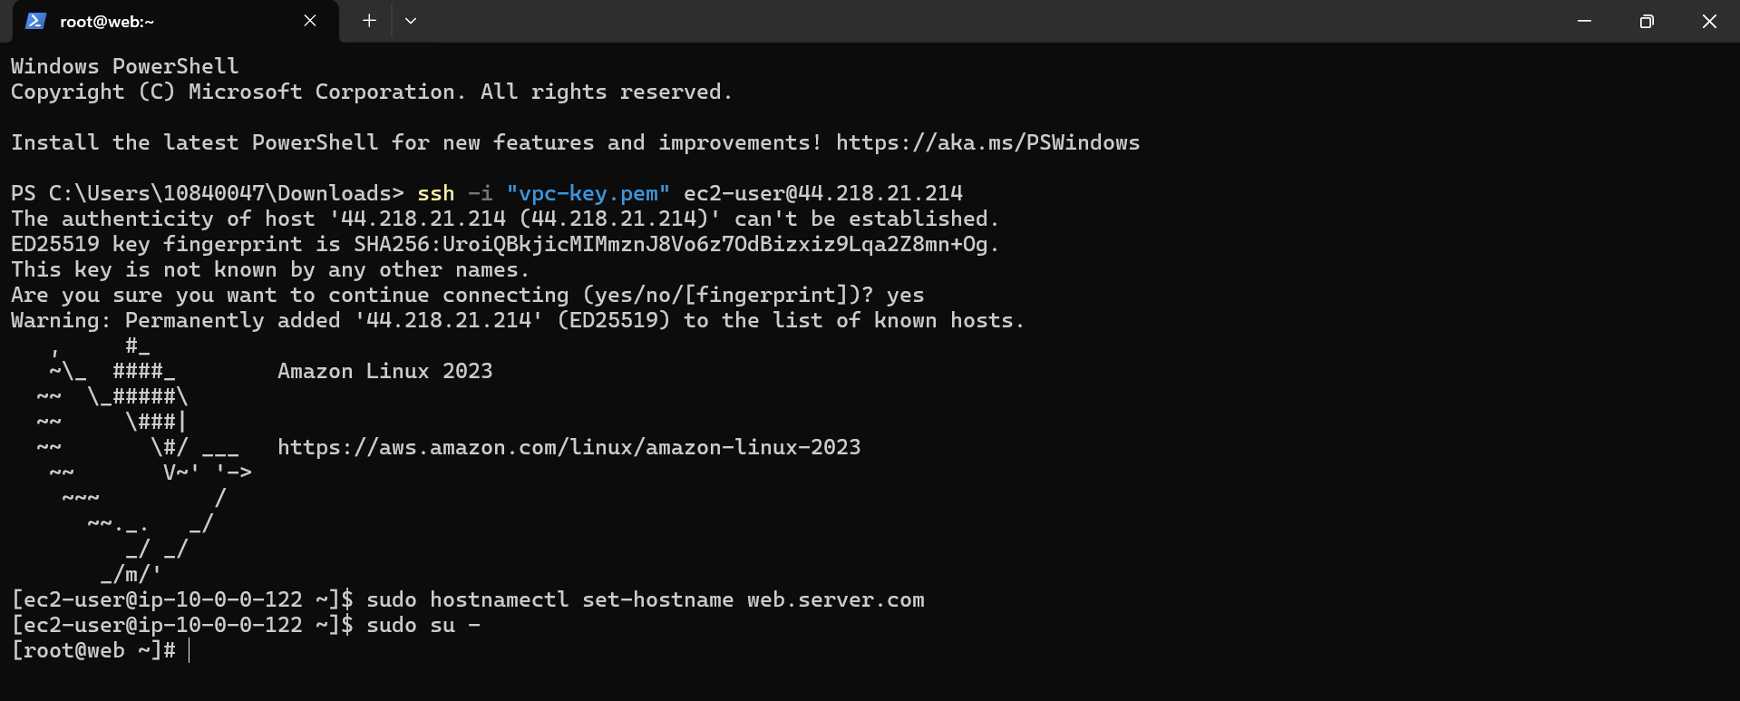

Then I copied the RSA Private key and pasted it in the vim vpc-key.pem (key pair name) and ran the command *chmod 400* to manage the permissions. 

Then I connected the database server inside my web server, and then I tried running command ping google.com to check if the internet was working in the database server or not and as we can see it’s not working.

Hence, the Database is not reachable publicly.

